**MALDA District:**

**Tourists spot:**

Jagjivanpur:

Jagjivinpur is an archaeological site located in Habibpur Block of Malda District. It is situated 41 km East of Malda District Headquarters. Some of the most important findings from Jagjivanpur are: The Copper-Plate Inscriptions of Pala Emperor Mahendrapaladeva and the Structural Remains of 9th-Century Buddhist Vihara : Nandadirghika-Udranga Mahavihara.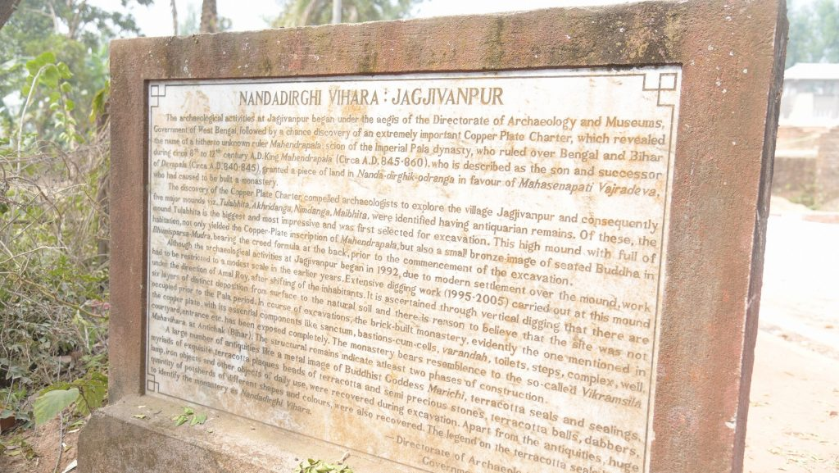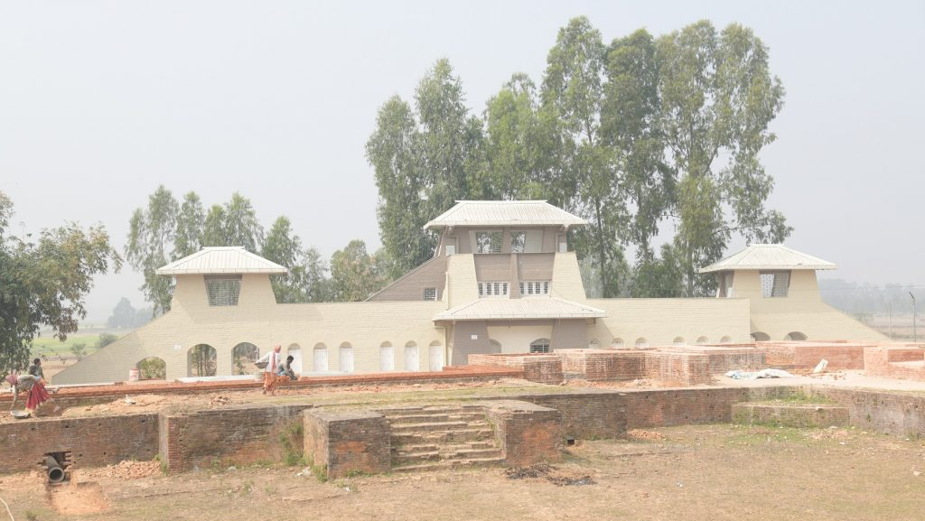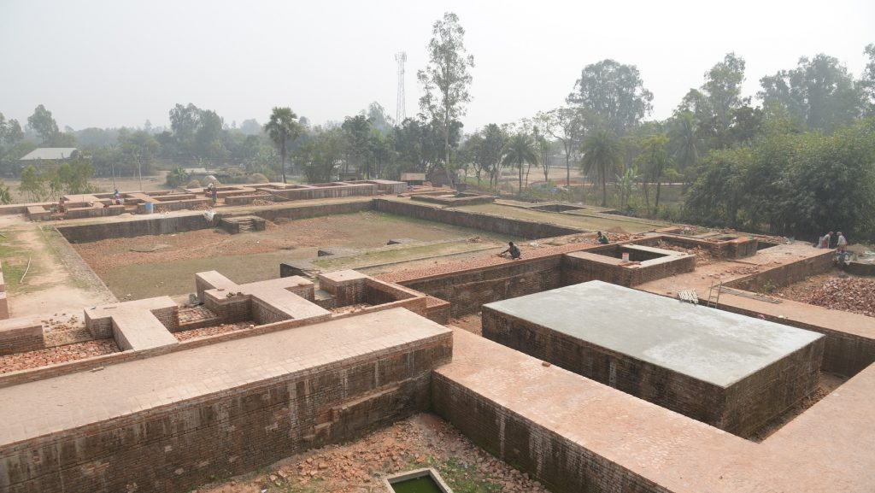

Adina Mosque:

Adina masjid, built in 1369 by sultan sikander shah, is one of India’s largest mosques. It is also one of the most developed mosques of the period. The orthodox design of Adina masjid is based on the 8th century Damascus mosque. The 88 brick arch arches and the 378 small domes of the masjid are supported by carved basalt from ancient Hindu temples.

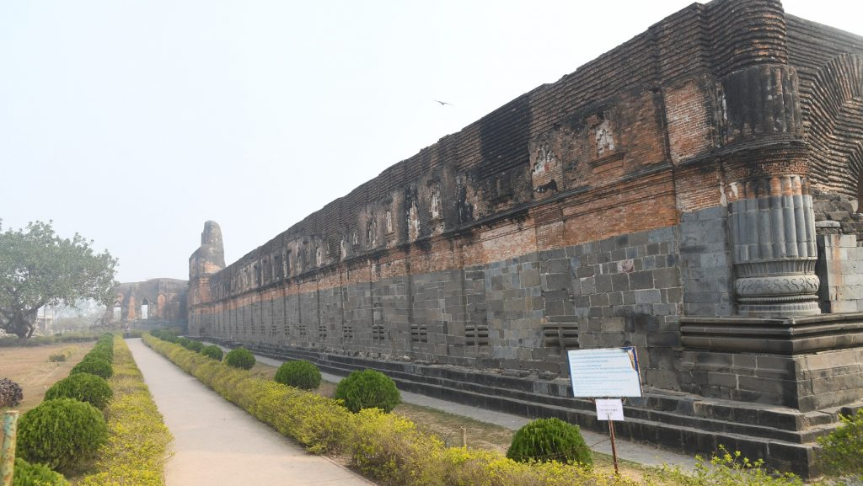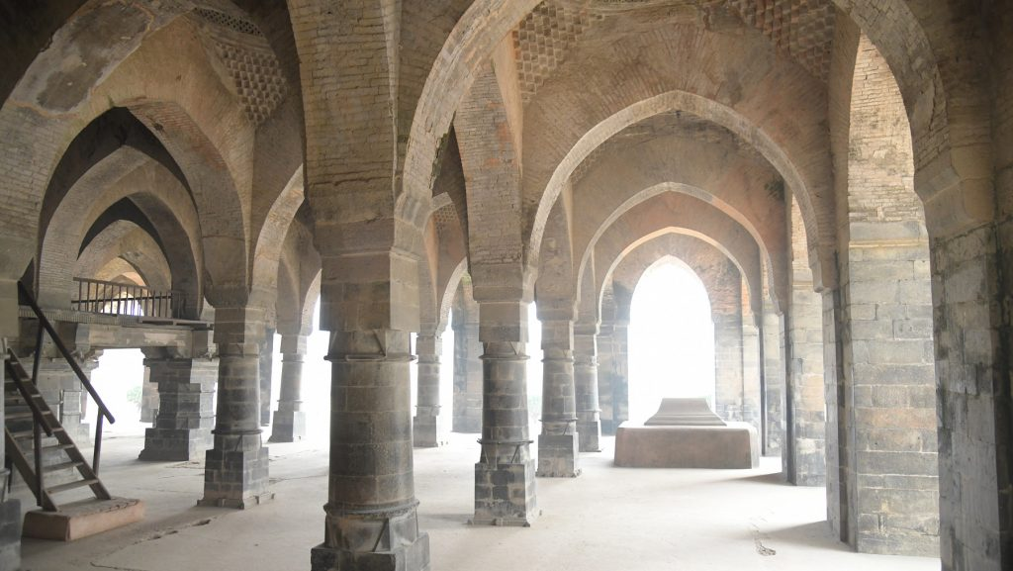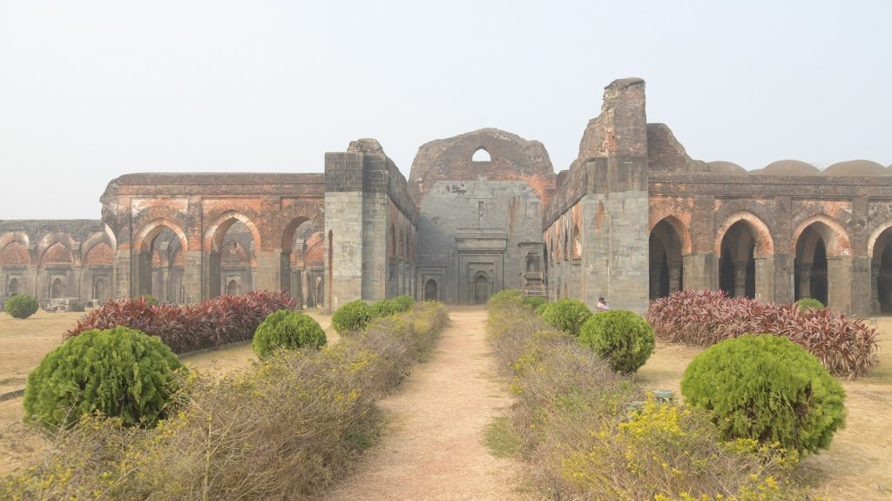

Ramkeli:

Ramkeli is 14 km south from Malda. A small village on the road to Gour, Ramkeli is famous for being Sri Chaitanya’s temporary home. Sri Chaitanya was one of the great religious reformers of Bengal. He stayed in Ramkeli for a few days while on his way to Vrindavan.Sri Chaitanya's footprints are preserved in the temple, which is encircled by eight 'kundas' or tanks: Rupsagar,Shyamkunda,Radhakunda,Lalitakunda,Bishakhakunda,Surabhikunda,Ranjakund,Indulekhakunda.

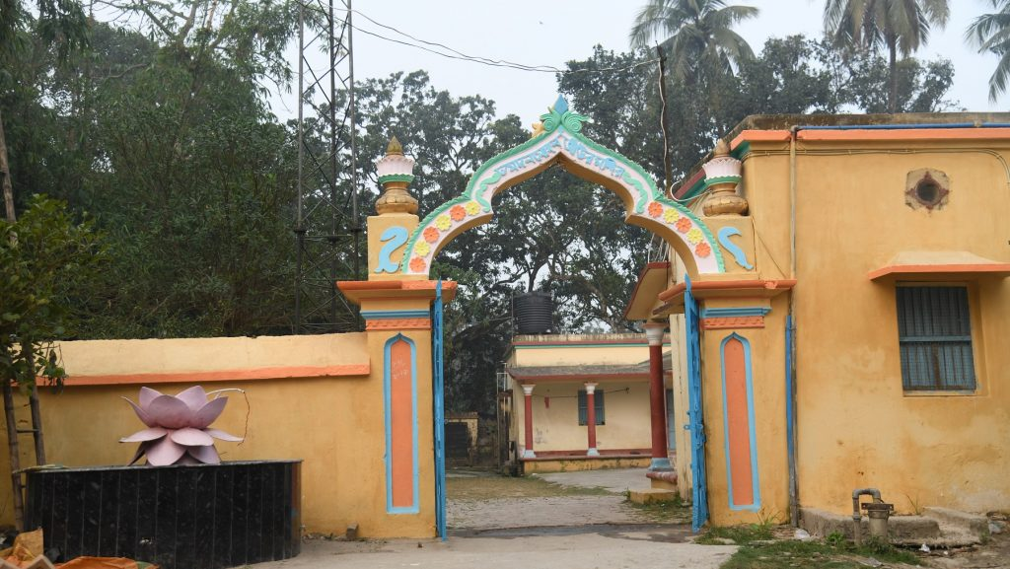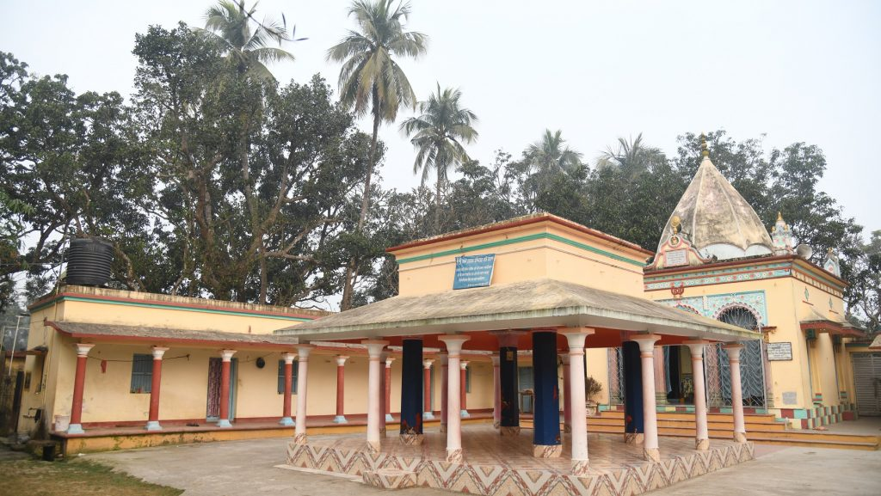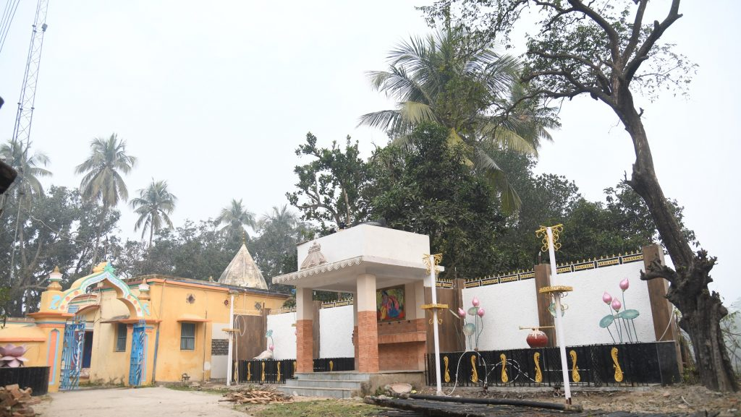

 Pirana Pir:

Pirana Pir  is a dargah of Khawaja Akhi Siraj Aainae Hind in the Malda district of West Bengal, situated 6.5 km southwest of Malda Town. Hazrat Sheikh Khawaja Usman Akhi Sirajuddin Chisty (r.a) was a 14th-century Sufi saint from Gour and held the position of khalifa under Hazrat Nizamuddin Auliya Mahboob-e-Ilahi (r.a). Acknowledged for his role in organizing the Chishti Silsila in Bengal at the behest of his sheikh, he remains a notable figure in Sufi history.

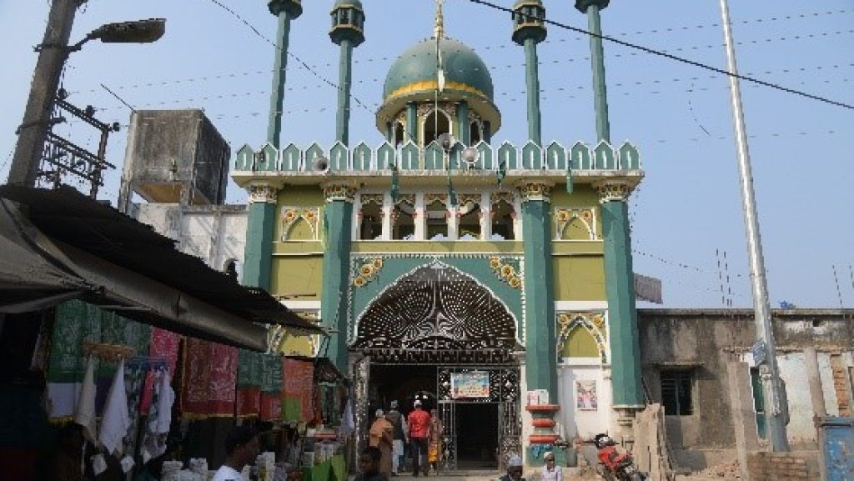

Baroduari / Boro Sona Mosque: 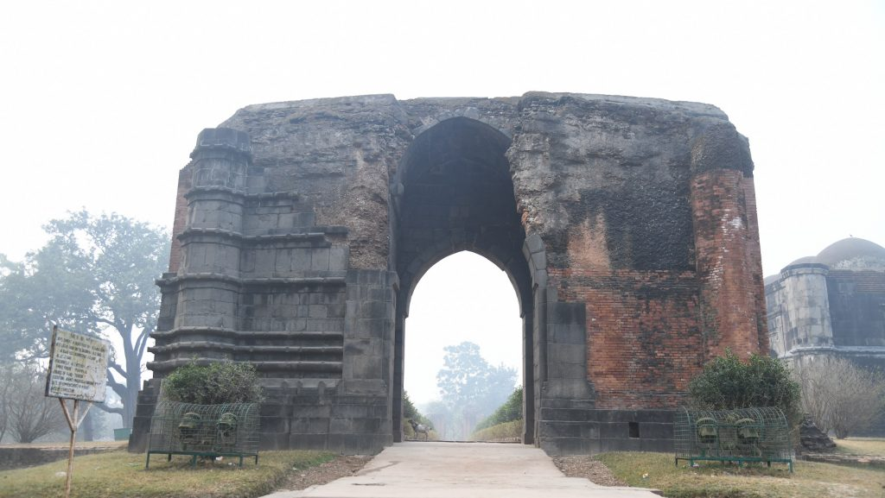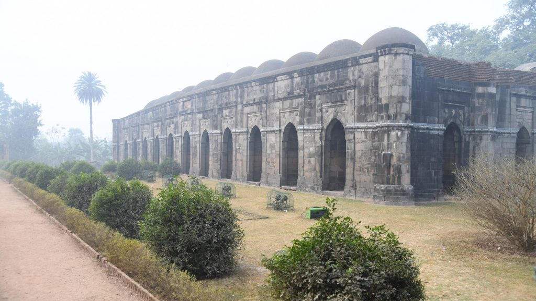

Baroduari Mosque is located about half a kilometer from Ramkeli. This mosque is a huge rectangular structure made of brick and stone. It is the biggest monument in Gour and is also known as the ‘12 Doors of Baroduari’. Although the name means ‘12 Doors’, this monument actually consists of 11 doors. The mosque is 50.4 m in length, 22.8 m in width, and 12 m in height. The construction of the mosque began in 1526 under the leadership of Allauddin Hussain Shah. It was completed by his son, Nasiruddin Nasir Nusrat Shah, in 1526. Due to its Indo-Arabic architecture and ornate stone carvings, Baroduari is a tourist attraction.

Dakhil Darwaja:

Built in 1425, it is one of the most important Muslim monuments in the city. Constructed of tiny red bricks and terra cotta, this imposing edifice stands over 21 meters tall and 34 meters wide. At its four corners, it is topped by five-story towers. It was once the main gate of a fort, and opens through embankments that surround it. At the southeast corner, a 20 meter high wall encircles the ruins of a former palace. This is where cannons were fired from in the past, which is why the gate also became known as the salaami darwaza.

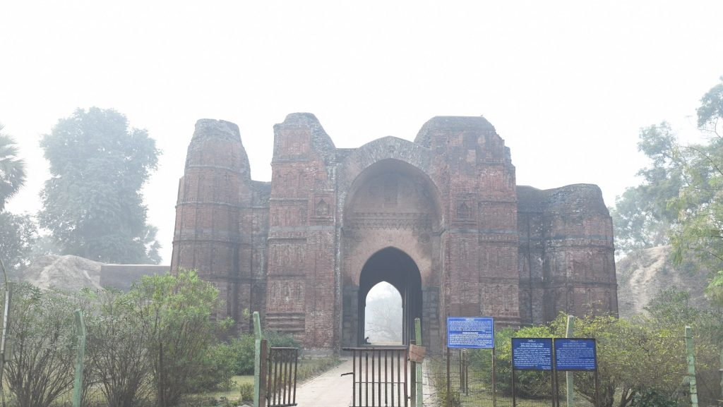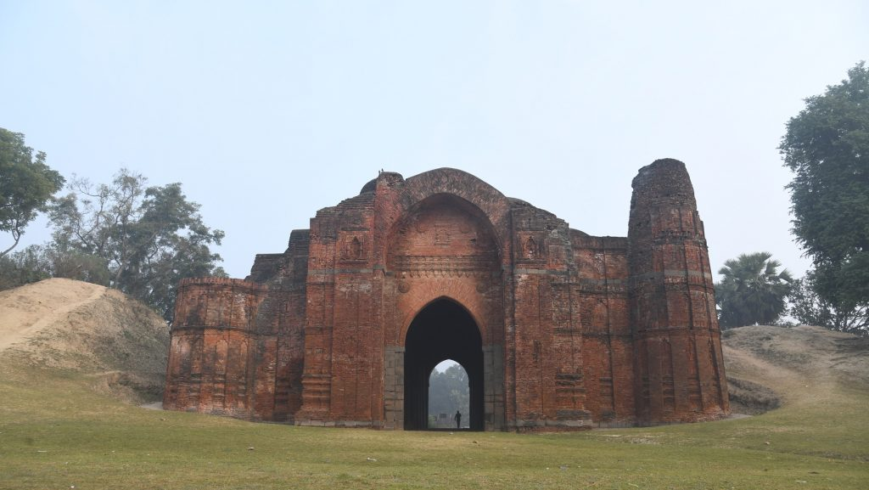

Firoz Minar:

Feroze Minar is a five-storey Qutb Minar like tower, 26 m high and 19 m in circumference. It has twelve adjacent faces each in the first three storeys. The top two storeys of the Qutb Minar style tower are circular. A spiral flight of 84 steps leads to the top. Built in 1485-89 by sultan saifuddin feroze shah, the walls of the minar are covered with intricately carved terracotta. The minar is also called the pir-ahsa-minar or the chiragdani.

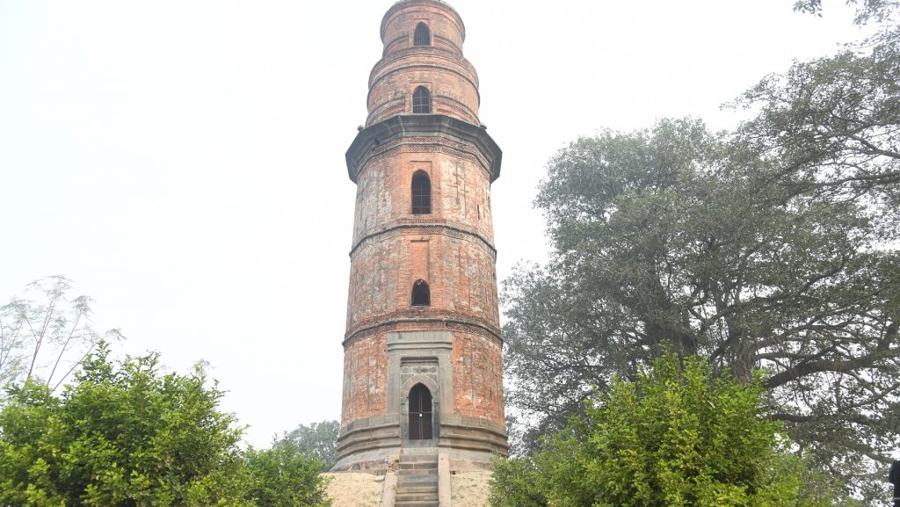

Chika Mosque:

The Chika Mosque was constructed in 1475 by Sultan Yusuf Shah. The mosque got its name from the large number of bats that used to inhabit it. The mosque is a one-room structure, which is now almost completely ruined. The beautiful ornamental carvings on its walls and the pictures of Hindu idols on its stonework of doorways and lintels can still be partially seen. The mosque also has elements of Hindu temple architecture.

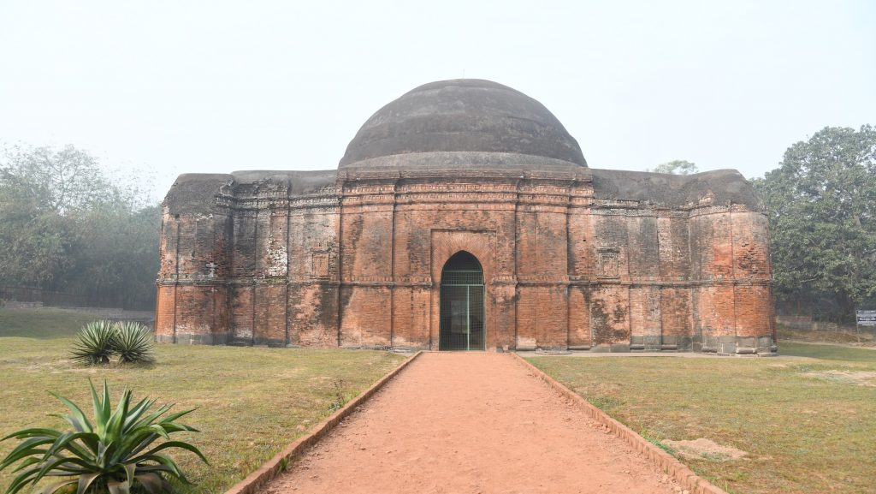

Luko Churi Gate:

The Lukochuri Gate or Lakhchhipi Darwaza is situated to the southeast of Kadam Rasool mosque. It was constructed by Shah Shuja in 1655 in Mughal architecture style. The name Lakhchhipi Darwaza comes from a royal game of hide and seek played by the Sultan with his wives. Another school of historians claim that it was constructed in 1522 by Allauddin Hussain Shah. The Darwaza is located on the east side of the Royal Palace. The double-storey Darwaza functioned as the main gate to the Palace. Its innovative architecture makes it a fascinating place to visit. 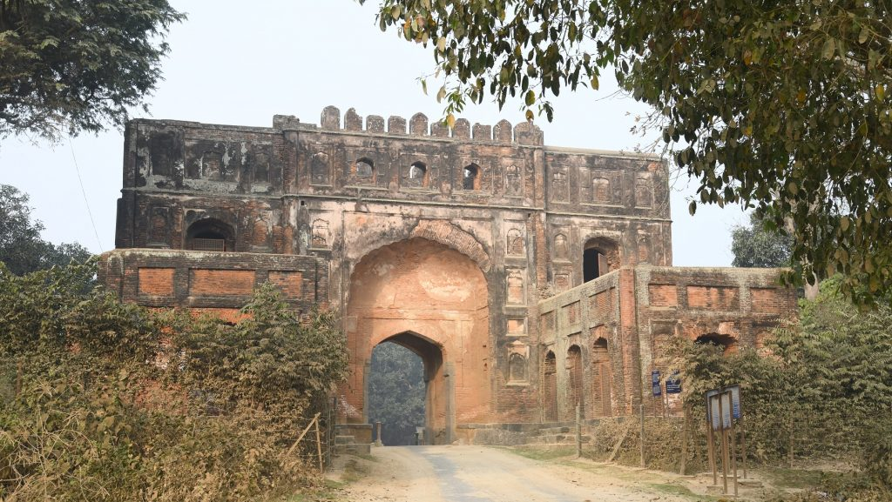

Quadam Rasul Mosque:

Fateh Khan’s tomb, built in the 17th century in the style of Hindu Chala, is located opposite the Kadam Rashool Mosque. Fateh Khan was a commander in Aurangzeb's army. Nearby is the graceful Tantipara mosque, with its intricately carved terracotta.

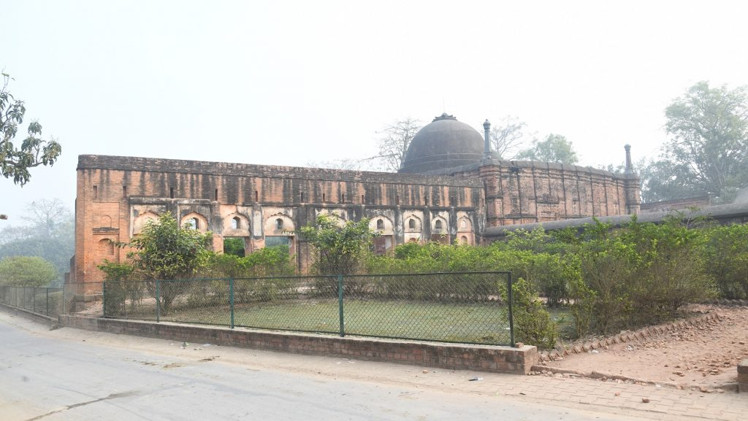

Gumti Darwaza: 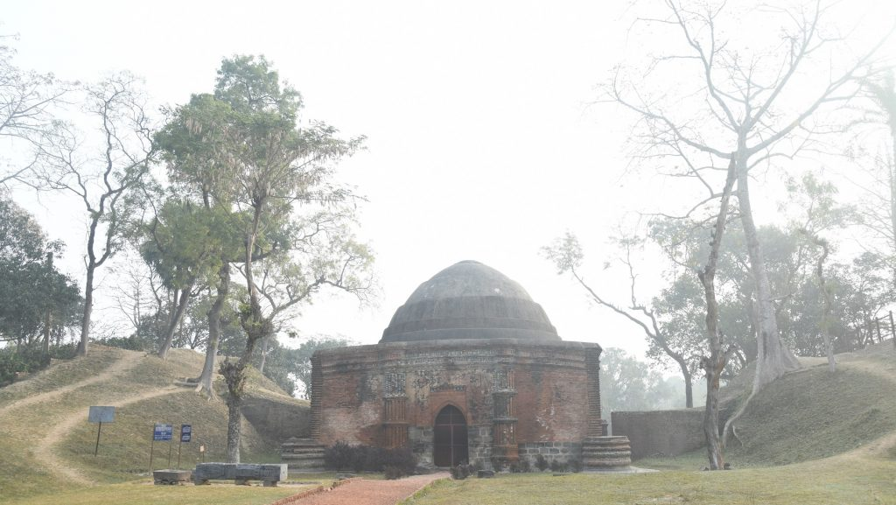

Located northeast of the chika mosque, the gumti darwaza dates back to 1512 when it was constructed under the leadership of Allauddin Hussain Shah. Constructed of brick and terra-cotta, its once vibrant colors are still partially visible. According to legend, the darwaza was decorated with real gold. The darwaza is now closed to the general public.

Malda Museum:

The Malda Museum is one of the archaeological museums of West Bengal. Founded in 1937, the museum is located at English Bazar, Malda District, Malda, West Bengal. The Malda Museum was originally a collection of historical artifacts found in the district. Initially, the museum was located in the premises of Malda district library. Later, the museum moved to its current building adjacent to the library. The Malda museum was given its own status as a museum under the state directorate of archaeology of West Bengal.

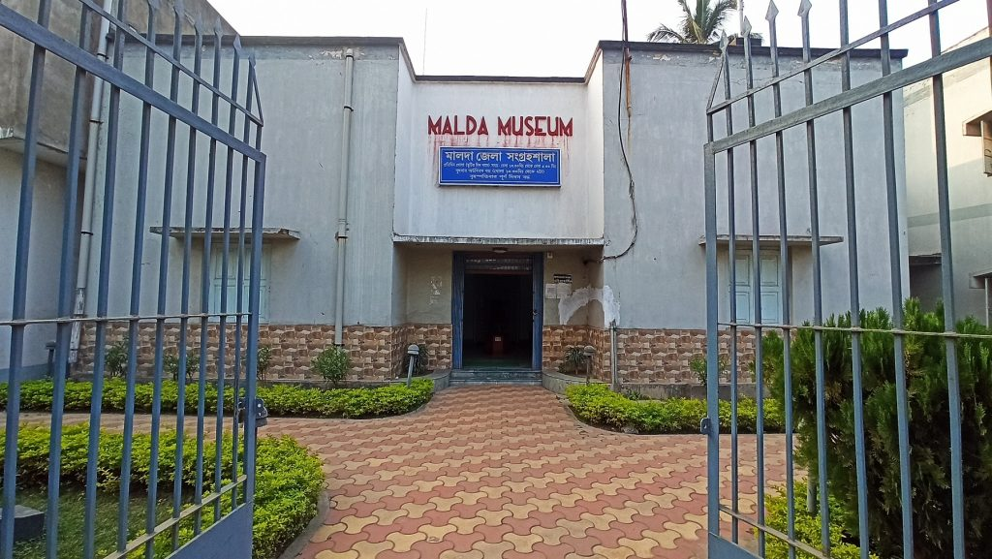 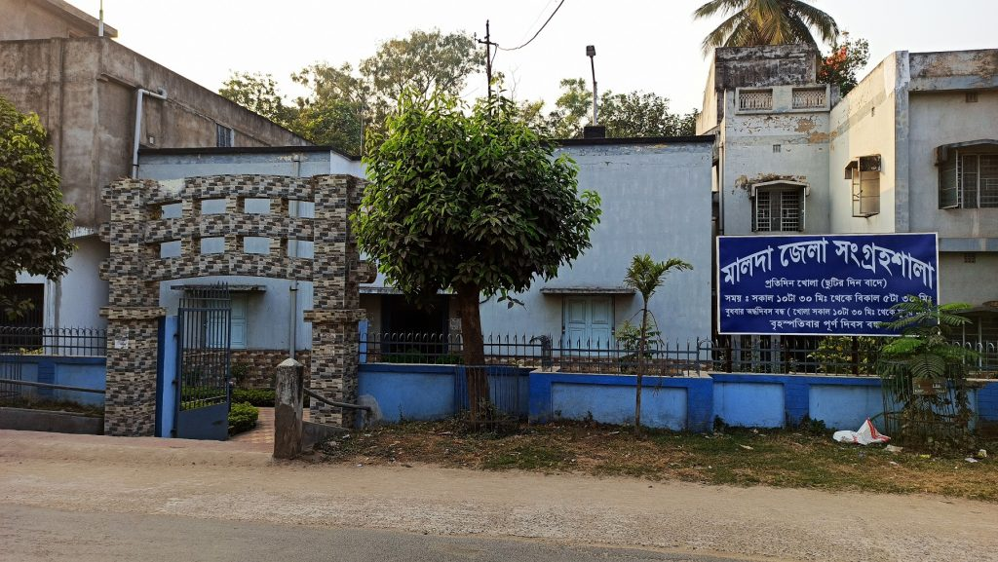

Adina Eco Tourism Park:

Upcoming attraction at Adina, Gazole, an eco-park completely nature friendly and filled with greenery. A special attraction is an inside road, social forest, Ornamental plants, Seating in greeneries, and a tank full of colorful fishes. 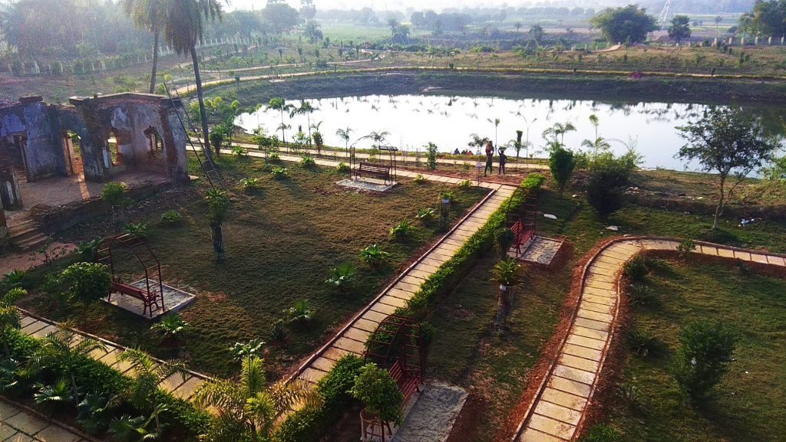 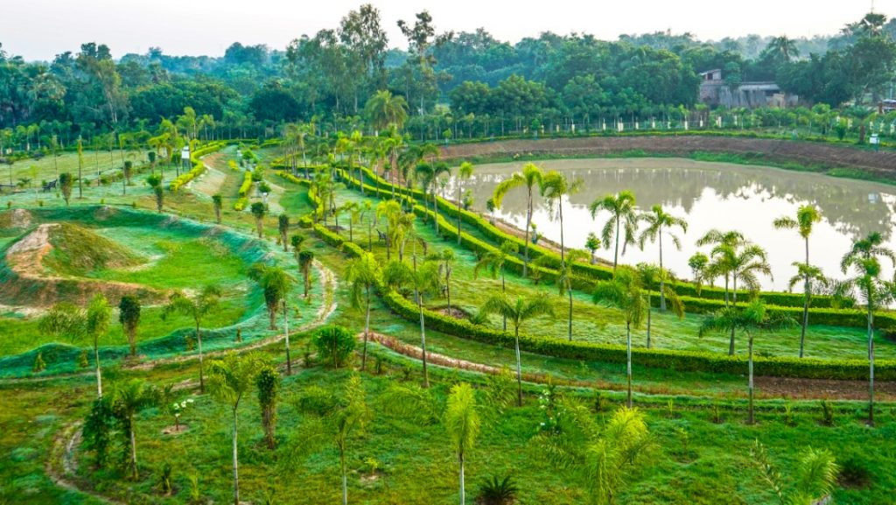

Eklakhi Mosque:

The most graceful structure in Pandua is the 'Eklakhi mosque'. It is one of the first'square brick tombs' in Bengal, with Ganesha carved on the door.

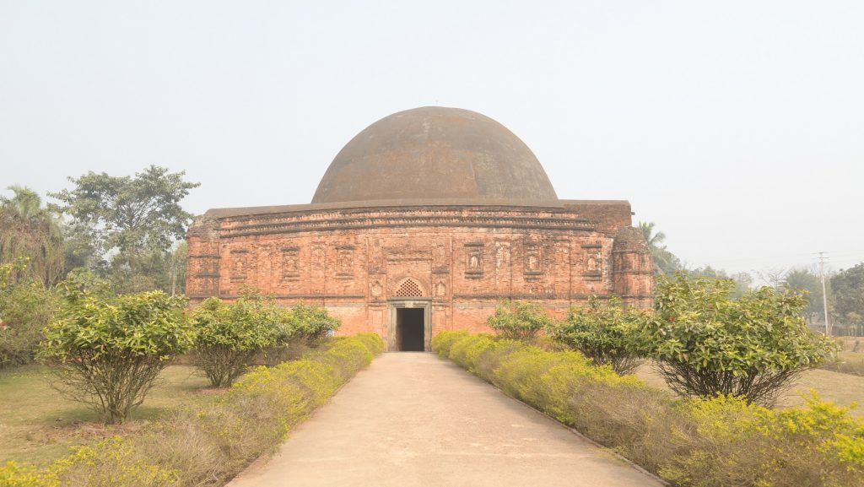

**Uttar Dinajpur district:**

**Tourist Spots:**

Bahin Zamindar Bari:

Located at Bahin Village, Raiganj block, Uttar Dinajpur, West Bengal. The house is situated on the banks of Nagar river, Raiganj. The house is one of the important historical places of North Dinajpur. The house is located at the border of the state of Bihar. The house was constructed by Bahin Zamindar Ishwar Chandra Chowdhury. The house is constructed of bricks. The house has large rooms and verandah. The house was declared as a heritage building by the West Bengal heritage commission in 2011.

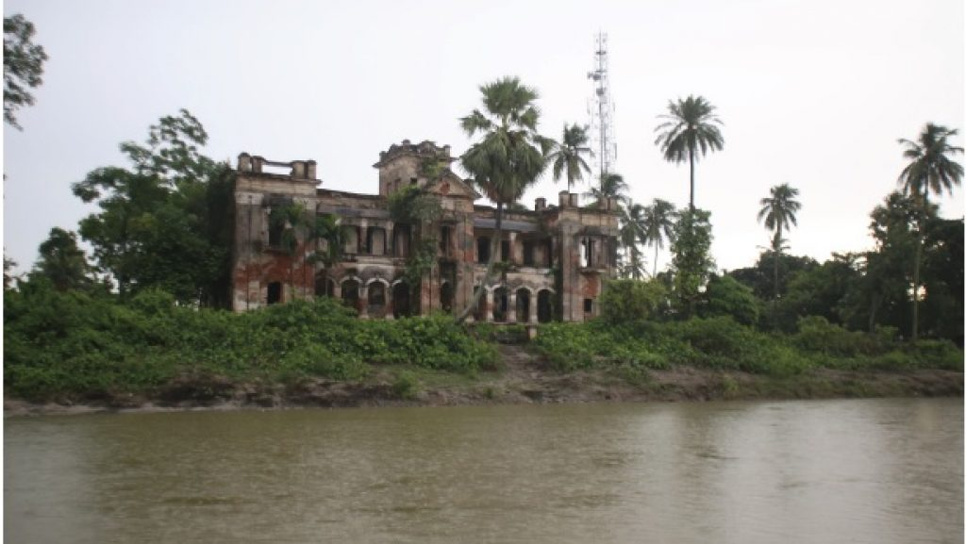

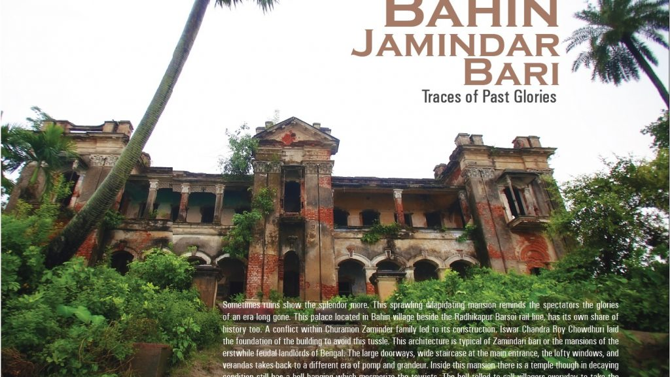

Sap Nikla Forest:

Sap Nikla forest falls under the Chopra block and is located 22 km from the Islampur. The forest type of Sap Nikla forest is mostly Northern tropical Most mixed deciduous forest. The distribution of the forest is very variable and mostly found in pockets. There are few pockets of natural forest of 282.11 Acres. Many tourists visit this forest and lake for sightseeing. Panoramic view of nearby areas is very fascinating.



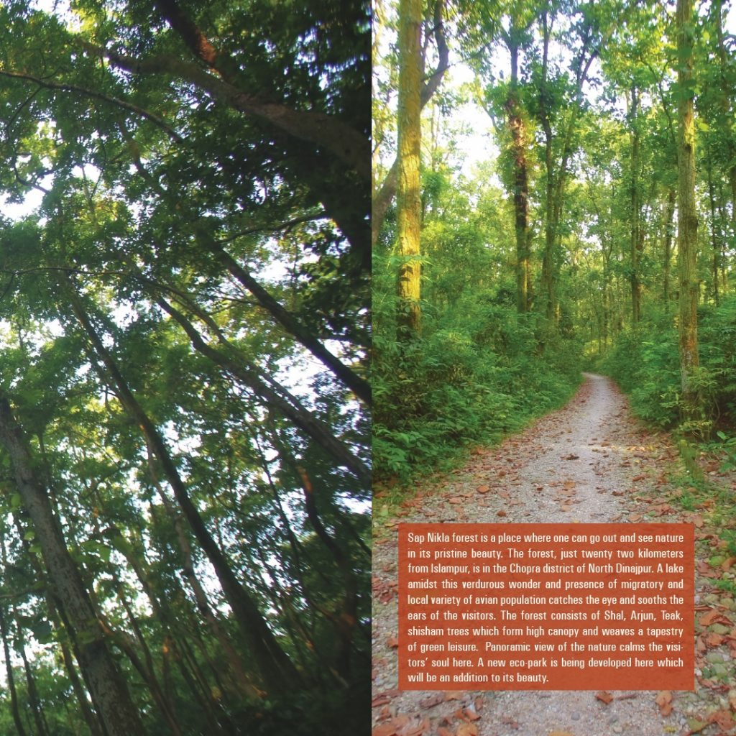

# Kunore

Kunore is a medium-sized village located in Uttar Dinajpur District.It is well-known for its clay /terracotta works. The clay used for decoration is from tea gardens. Craftsmen produce tiles and tubs for small plants. Some also manufacture telephone stands, lamp shades, fancy idols, and decorative tiles. The motifs recur across the items. The four most common motifs are tribal woman with child, palm tree, figures of Ganesha or typical motifs from Bengal, designs like 'lata' which means 'blooming creepers' and 'kalka' which means 'mango motif'. Terracotta works in Kunore are very recent, but the people who migrated to this area have been involved in this craft for generations.

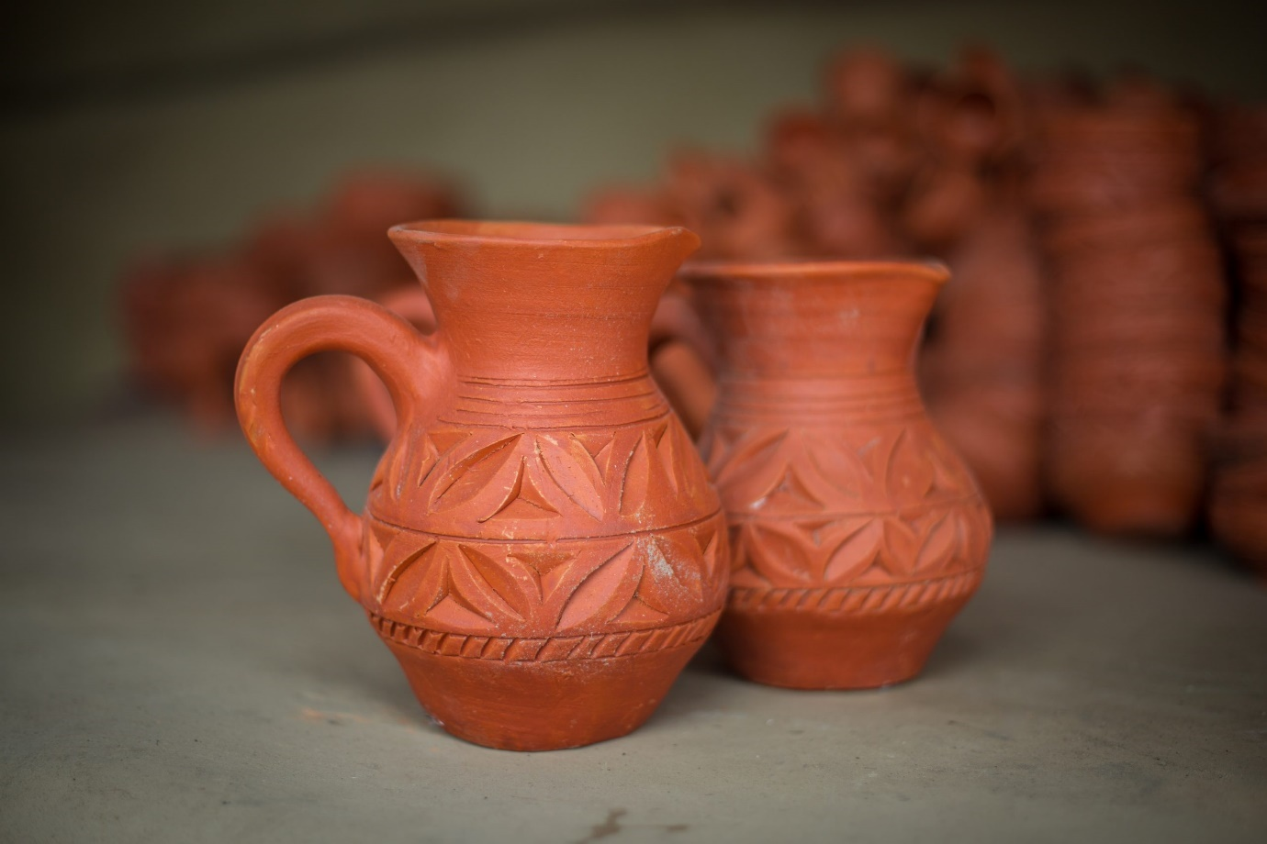

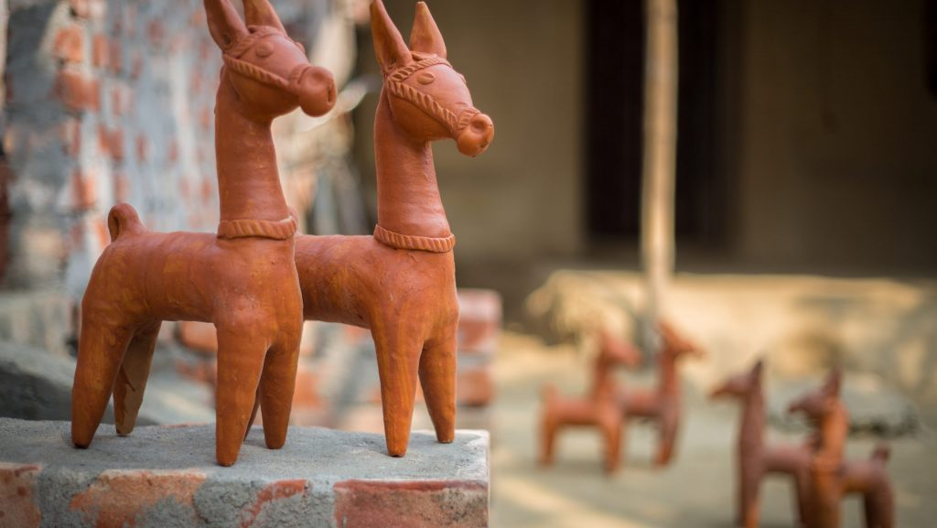

Karnajora Museum and Park:

The Karnajora Museum, Pottery Work, Terra cotta Sculptures are other attractions in North Dinajpur, which is renowned for its collections of rare flora and fauna.

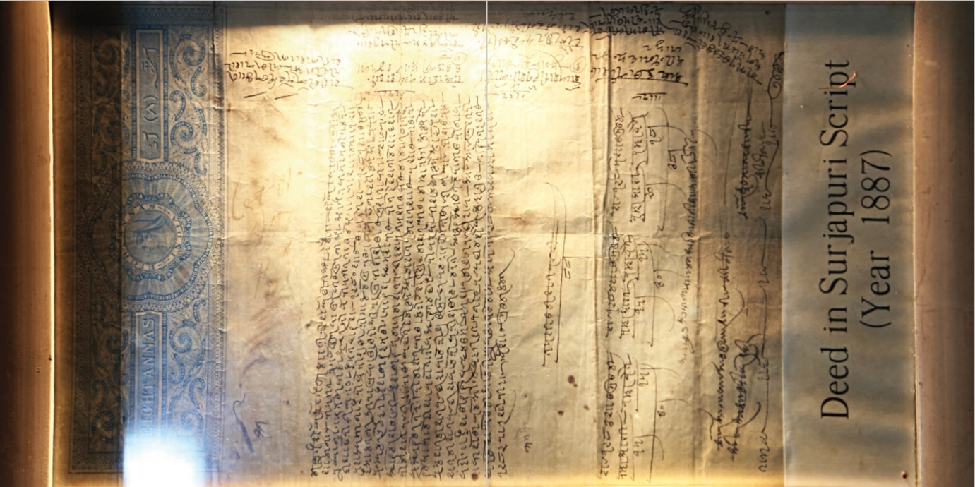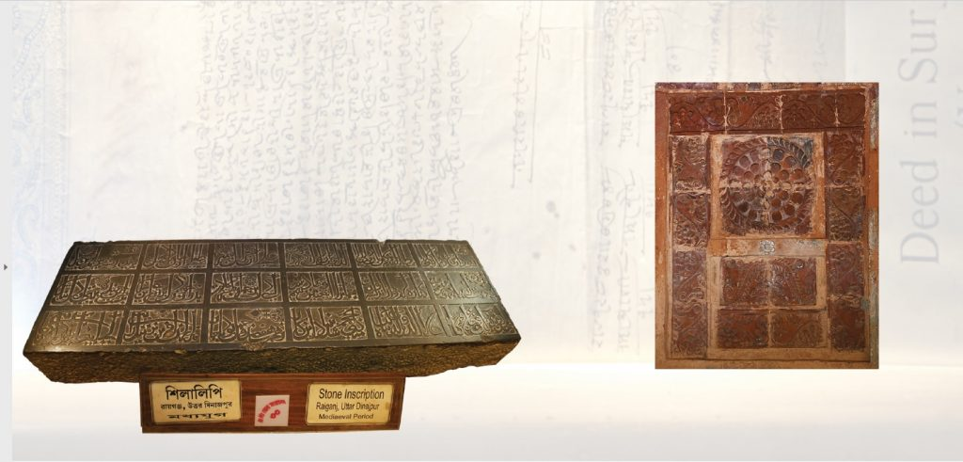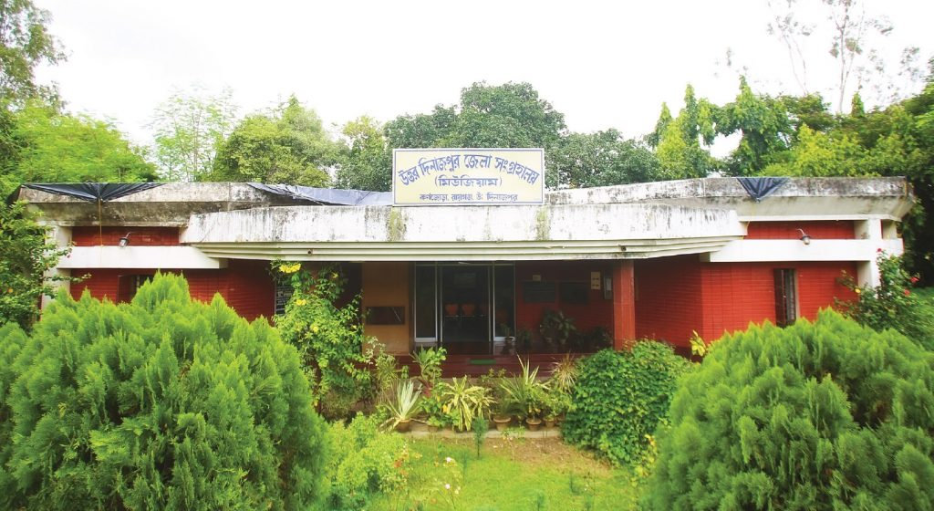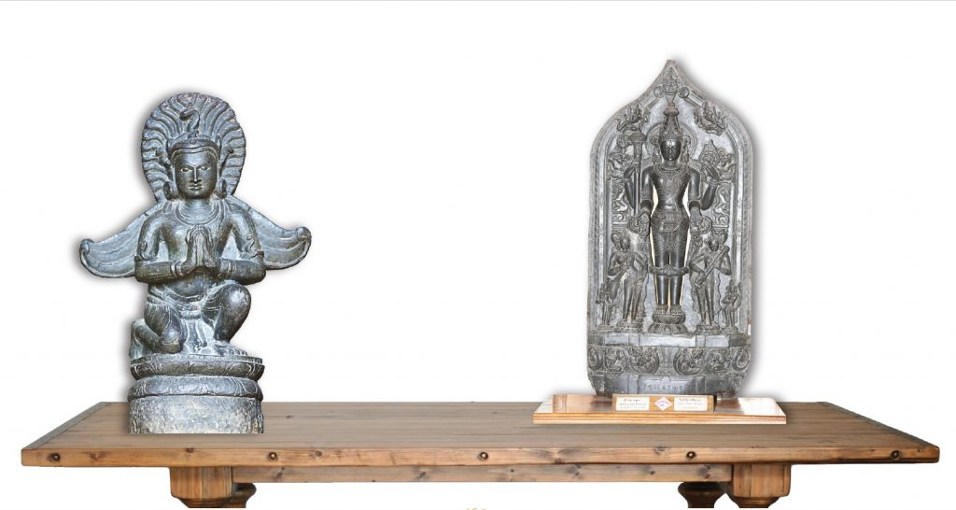

Kulik Bird Sanctuary, Raiganj:

Kulik Bird Sanctuary, commonly known as Raiganj Wildlife Sanctuary is a paradise for bird watchers. Located near Raiganj, Uttar Dinajpur, West Bengal, this sanctuary is home to nearly 164 species of birds, with around 70,000-80,000 migrating birds visiting the sanctuary every year. The sanctuary, which covers an area of 1,30 sq. km, is often referred to as Asia’s second largest bird sanctuary. The habitat of the Kulik Bird Sanctuary, which takes its shape from the English letter “U,” is connected to the River Kulik by a complex network of man-made canals.

Raiganj Bird Sanctuary has an area of 35 Acres and a buffer of 286.23 Acres, making it the perfect habitat for a wide variety of colourful birds. Residents of the sanctuary include the flycatcher, kite, owl, woodpecker, kingfisher, drongoes, and many more. In addition to birds, this sanctuary is also home to a variety of migratory birds from coastal areas and south Asian countries.

In addition to birds, the exotic collections of flora and wildlife of the sanctuary are equally fascinating.

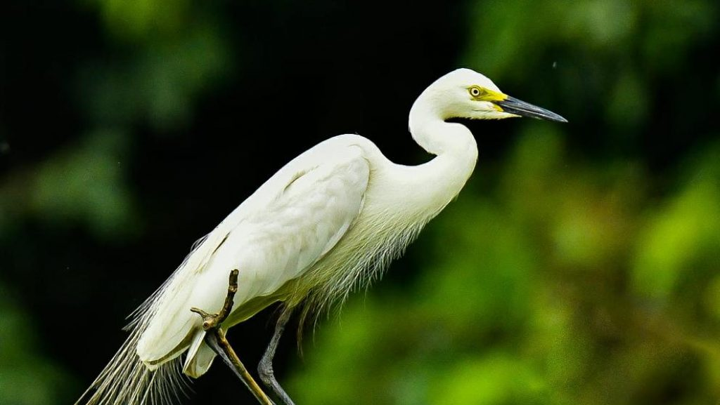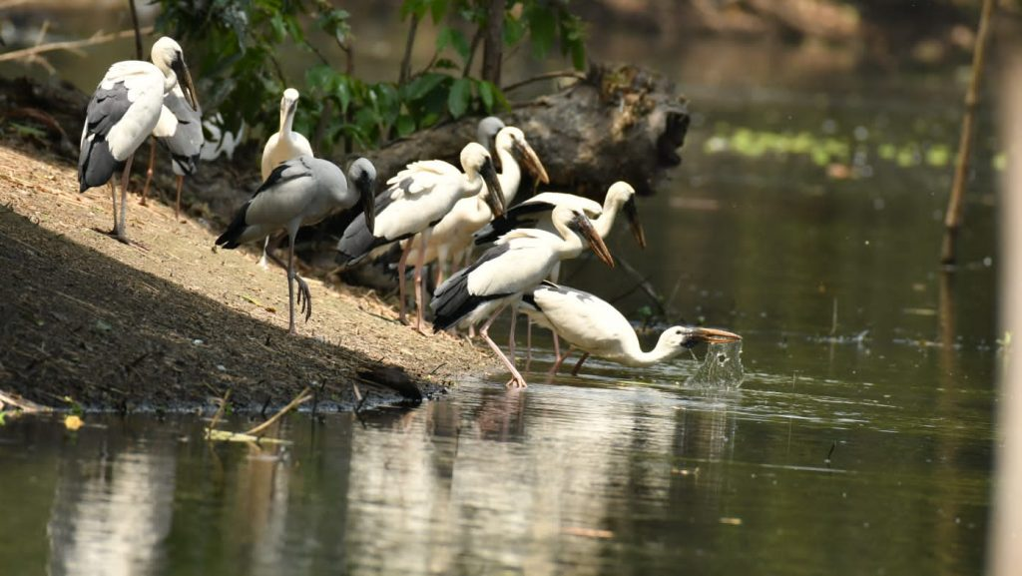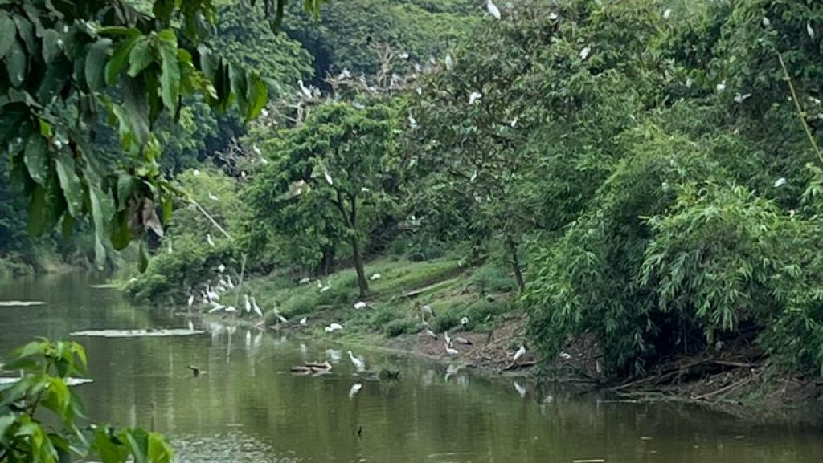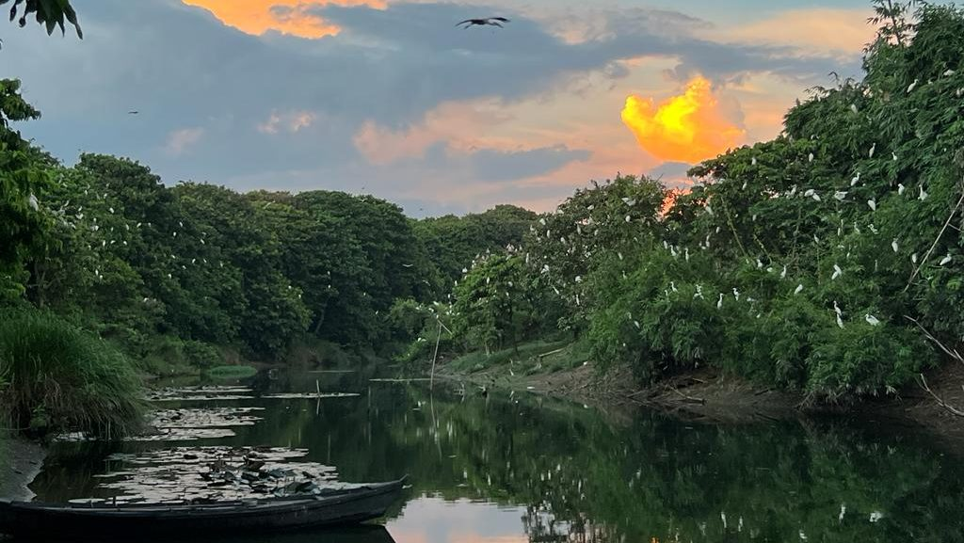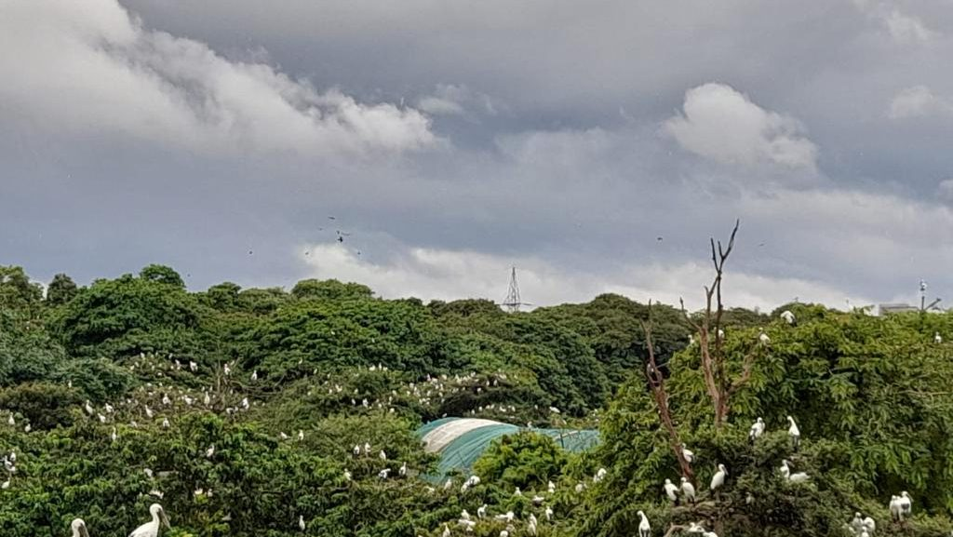

**Dakshin Dinajpur:**

Hili international check post:

Hili is a Land Port and Border Checkpoint on the Bangladesh border with India. Developed (2018) as an Integrated Checkpoint (ICP), Hili facilitates the free flow of goods and people across the border. Part of Hili is situated in Bangladesh. On the other hand, Hili Land Port (Hampur Upazila, Hili) is situated in Dinajpur District, Bangladesh. Significant trade takes place with trucks passing through Hili. There is a Customs office at Hili for export/import. Intergovernmental agreement on dry ports (IGA) is a 2013 UN treaty which aims to encourage cooperation in developing dry ports in Asia-Pacific region.

Hili is located on the India- Bangladesh border, commonly known as the porous border. About 2,216 km out of the total of 4.096 km India- Bangladesh border fall in West Bengal. About 252 km out of the international border falls in the West Bengal. Over 11,000 persons live near/around the zero line (Dinajpur, West Bengal).

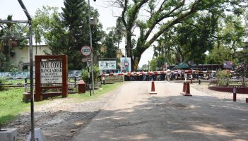

Angina Bird Sanctuary :

As the New Year approaches, Angina bird sanctuary under kumarganj blocks of south dinajpur district awaits to receive more tourists. During the winter season, more than 100 migratory birds arrive at angina wetland annually.

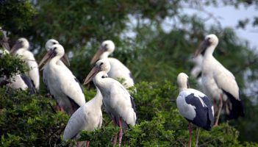

Bangar excavation site, Gangarampur:

The historical city of Bangarh is located in the state of West Bengal. Bangarh was one of the oldest cities in the area. The city was the administrative center of Kotivarshana Vishaya (Territorial division) which later became part of the larger administrative unit of pundravardhan bhukti. In the period of chandrans, varmans and senas, the capital of the Senas was in bangarh.After the defeat of the Senas by Muslims under the rule of bakhtiar khilji, the Senas made devkot as their capital where bakhtiar died.

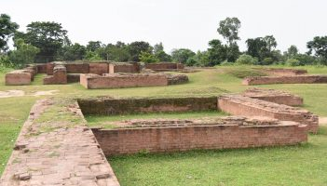

# Culture & Heritage

The 'Khan' is an age-old folk-cultural form popular in the 'Dinajpur' region. It is practiced by the rural population of the District, who are mostly members of the scheduled cast and scheduled tribe communities.

NATUA: practiced in a few villages of Kushmandi block, revolves around the love between Radha and Krishna.

**JANG GAN**: Folk songs composed in Dinajpuri & Surjapuri Dialect. Gangarampur & Kumarganj Blocks have artistes of Jang Gan.

The MOKHA DANCE is a mask dance performed by the rural people who represent different ethnic groups. The masks are made locally using the locally available wood. Currently, the main centre of this mask dance is Kushmandi Block. The masks of animals like Monkey, Tiger, Gods and Goddesses like Kali, Shiva, as well as some fictional characters like Bura, Buri are made. These masks were worn by the male dancers who were dressed in appropriate attire and performed. The dancers were accompanied by the drummers and flute players.

**HALNA – HALNANI:**

The main characters of this folk-opera are a rural man named Male Halna and a woman named Halnani. The folk artists of this district are very socially conscious and participate in all the government programs for social uplift, such as the DPEP, literacy campaign, health awareness, and family welfare programmes. The folk cultural performance is a major part of the annual Teesta-Ganga Utsav, a cultural festival organized by the Ministry of Information and Culture, where they share the stage with artists from the banks of the Ganges. The folk songs of this district are known as Baul, which can be heard in neighbouring districts such as Malda, Bhawaiya, Chatka, and Gambhira. Bauls can be seen performing all over the district. There is also a Baul Mela and Utsab held at Tapan Block in Nayabazar. There is now a forum for folk artists and performers in the District, which is similar to a state-level organisation.

**Murshidabad:**

Karnasubarna(Capital of Shashanka):

The capital of the Gauda Kingdom was Karnasuvarna, also known as Karnasubarna, which was the capital of Shashanka's reign during the 7th century AD. Shashanka was the first important ruler of ancient Bengal. After Shashanka’s death it was the jayaskandhavara of Bhaskaravarman, the king of Kamarupa probably for a short period

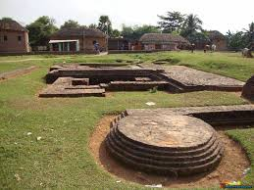 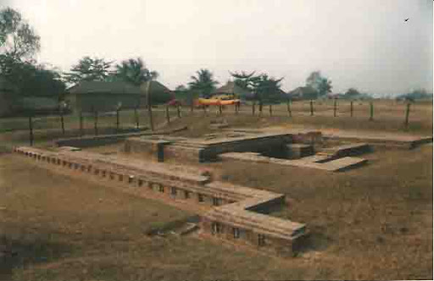 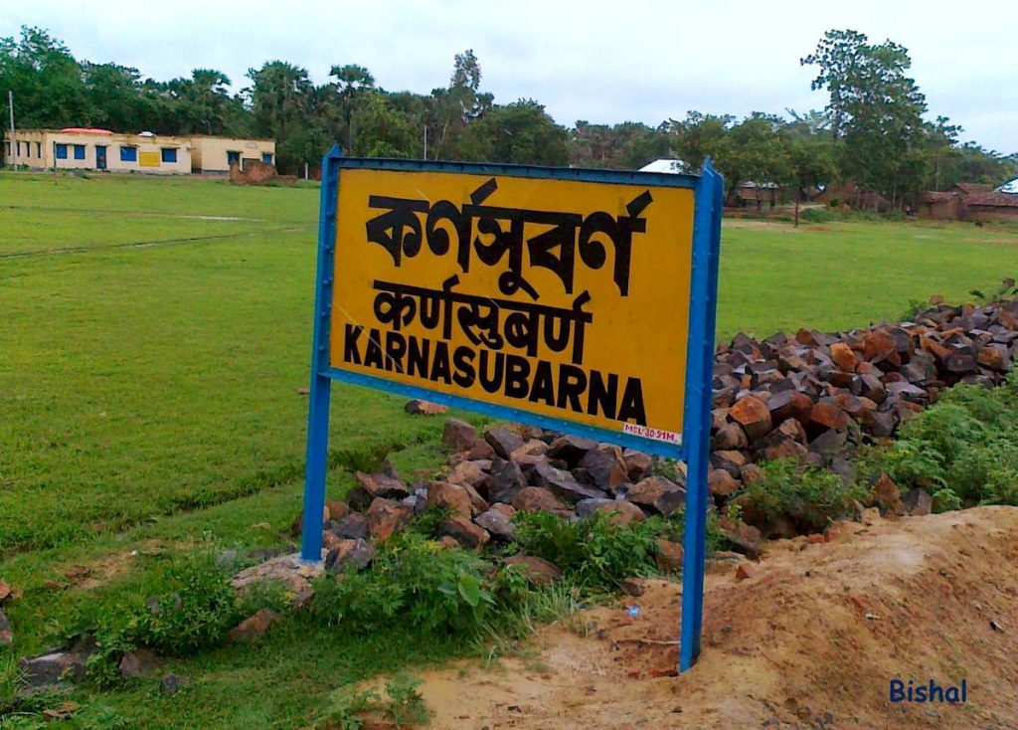

Sonarundi Rajbari:

Banwaribad raaj bari is a palace located in Sonarundi and Bonwaribad. Banwaribad raaj bari.

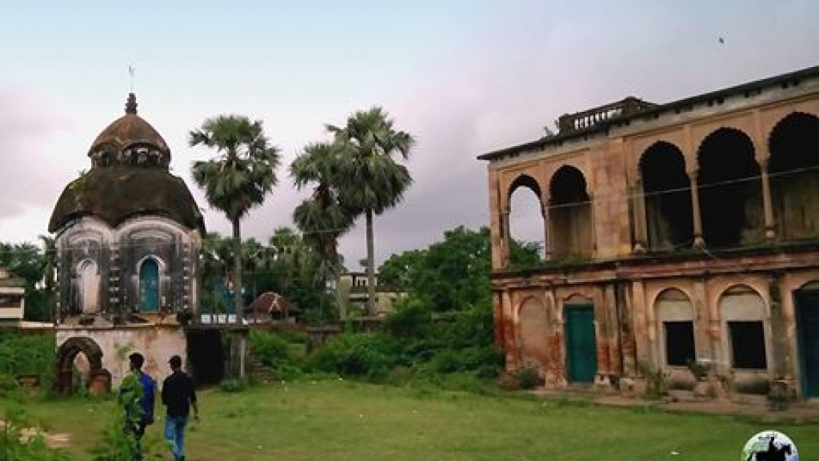

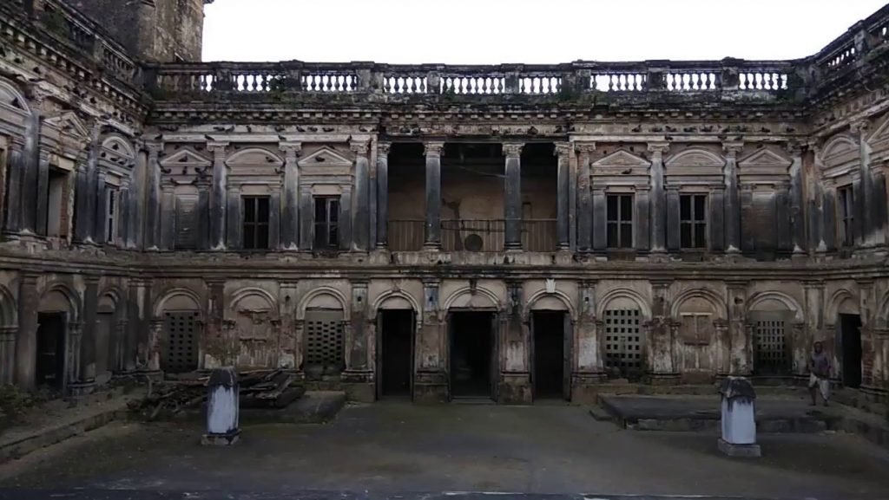

# Dahapara Dham:

Dahapara Ashram & Mandir is situated in the rural region of Murshidabad and is very beautiful. Surrounded by green mango groves, the ashram & mandir is surrounded by a variety of shady & leafy trees such as 'bakul flower' and 'chalta trees' which are very typical and emblematic of prabhu jagadbandhu centers which were founded by mahanam sampraday of india. The wood-apple tree can still be seen in the dahapara dham premises where jagadbandhursundar used to play pranks in his childhood. The sacred river Bhagirathi flows by Dahapara Ashram and Mandir at a short distance from the premises.

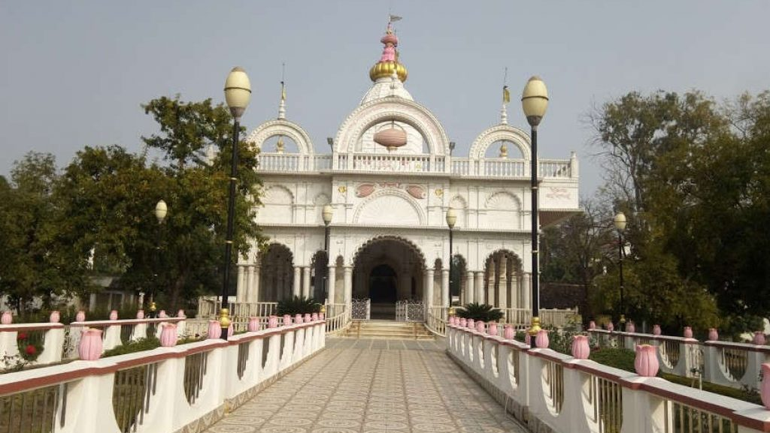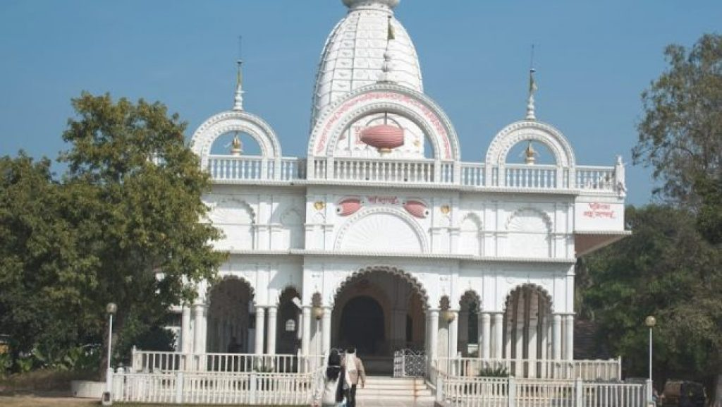

# Bishnupur Kalibari:

A picturesque temple situated on the bank of Bishnupur jheel, a very serene spot. The divine abode of Goddess Kali.

Armenian Church – Berhampore:

The oldest Armenian church in East India. Founded in 1757AD in Berhampore, Saidabad, West Bengal.

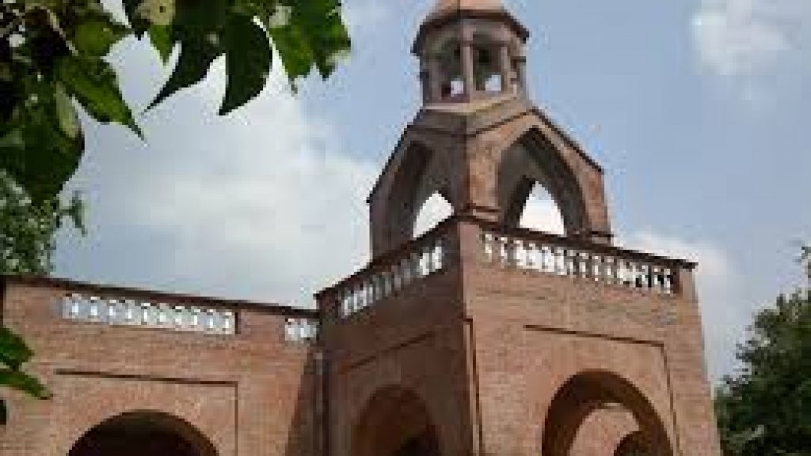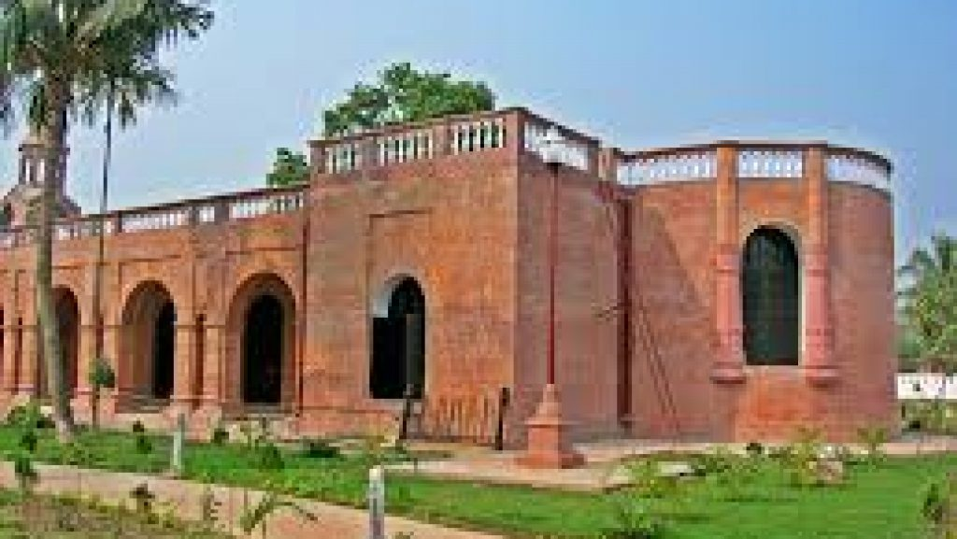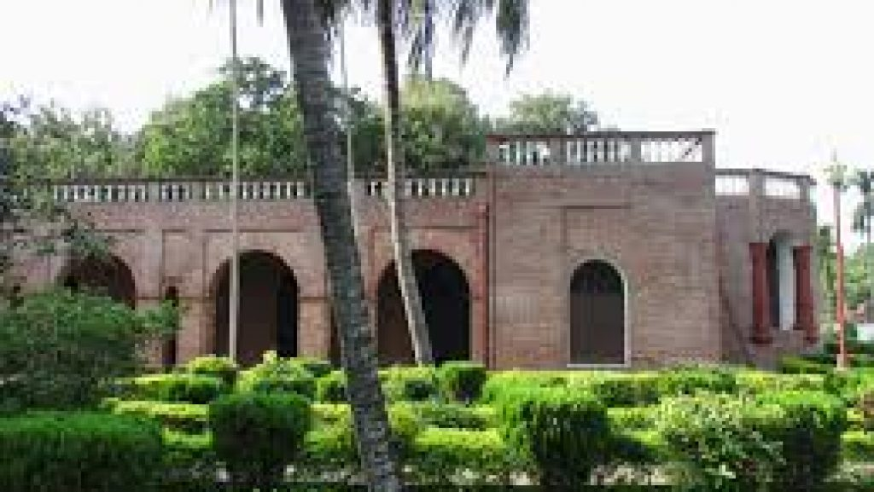

Tomb of Azimunnisa Begum:

Like her father, Azimunnisa is buried under the staircase of the Ruined mosque. Azimunnisa Begum, also known as Jinnatunnisa, was the daughter of Murshid Quli khan and the wife of the Nawab Sirajuddin-ud-Daula. 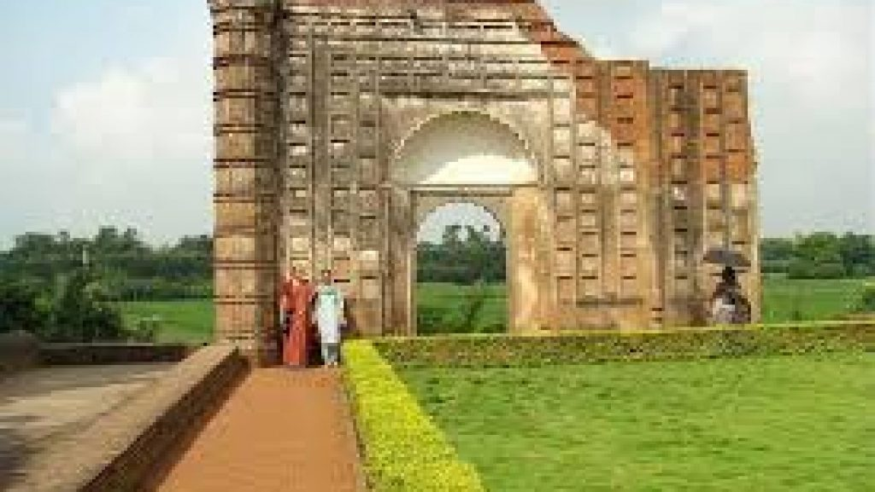 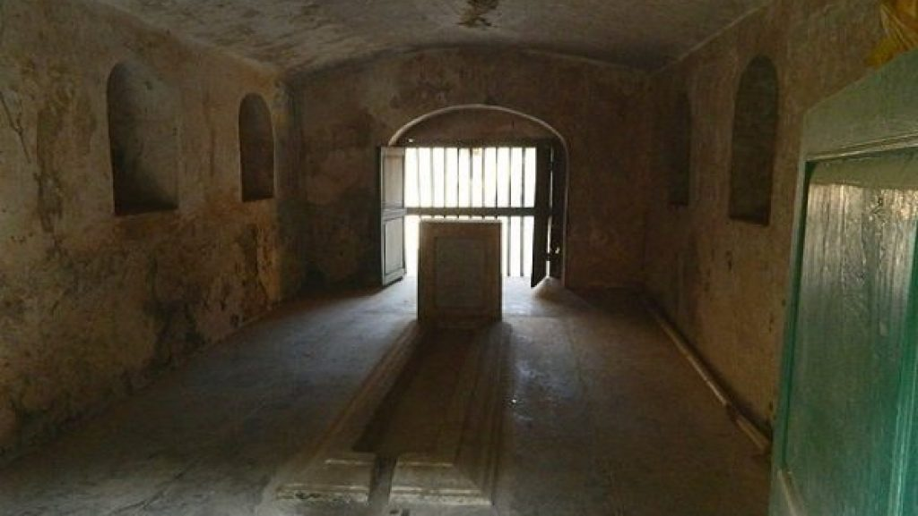

Jafraganj Cemetery:

Mir Jafar built the 3.51-acre cemetery over an enclosure with waved walls about a half-mile north of the nizamat fort campus and within the campus ofnamak haram deorhi. The cemetery houses the tombs of the later nawabs of Bengal of the najafi dynasty, beginning with the first nawab (Mir Jafar) and his family members, while the khushbagh (built by the Nawab (Alivardi Khan) of the afshar dynasty houses the tomb of the last nawab of Bengal and his family members. The cemetery is presently under the control and management of the Archaeological survey of India.

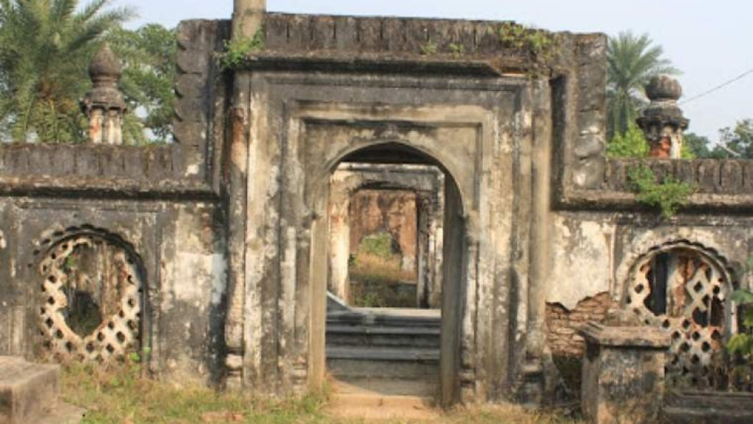 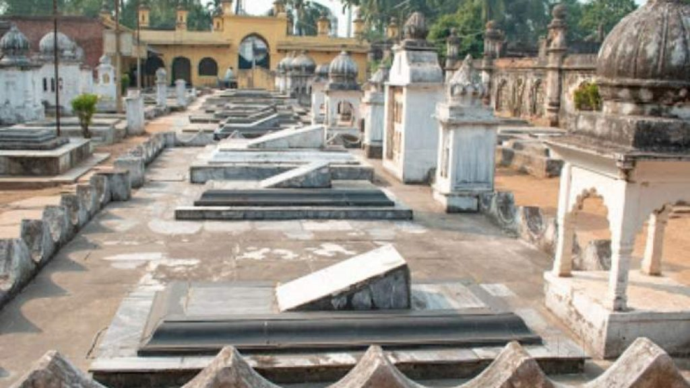

Futi Mosque:

Futi Mosque is a mosque in the city of Kumarpur, India which was built by Nawab Sarfaraz Khan in 1740 AD. The old Futi Masjid is one of the largest mosques in the town of Kumarpur and Murshidabad. It is about 3 quarters of a mile away from the grand and famous Hazarduari Palace. This grand mosque is 135 feet long and 38 feet broad.

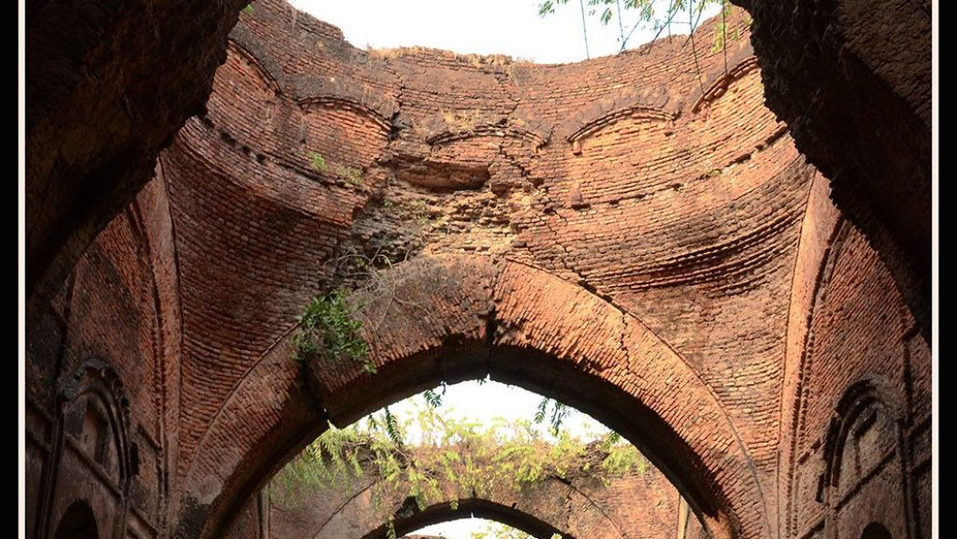 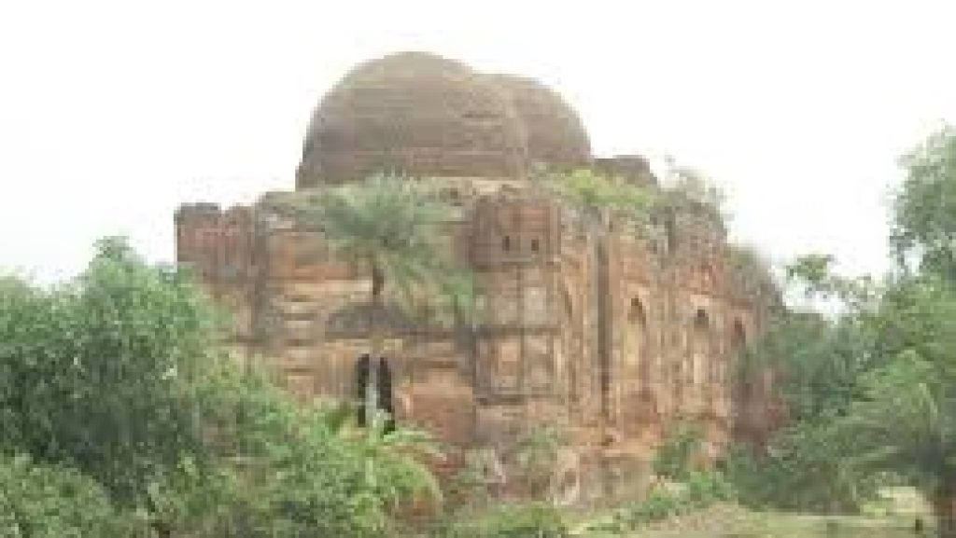

Nizamat Imambara:

The Nizamat Imambara is a Shia Muslim congregation hall in Murshidabad, India, which is the largest one in India and Bengal. The present Nizamat Imambara was constructed in 1847 AD by Nawab Mansur Ali Khan. It was built after the old Imambara built by Nawab Siraj ud-Daulah was destroyed by the fires of 1842 and 1846.

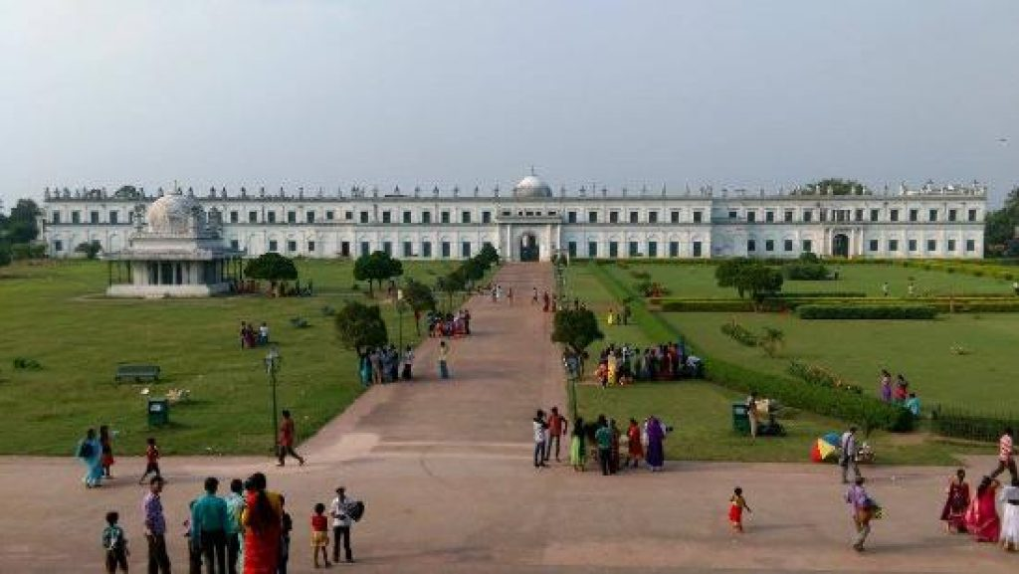 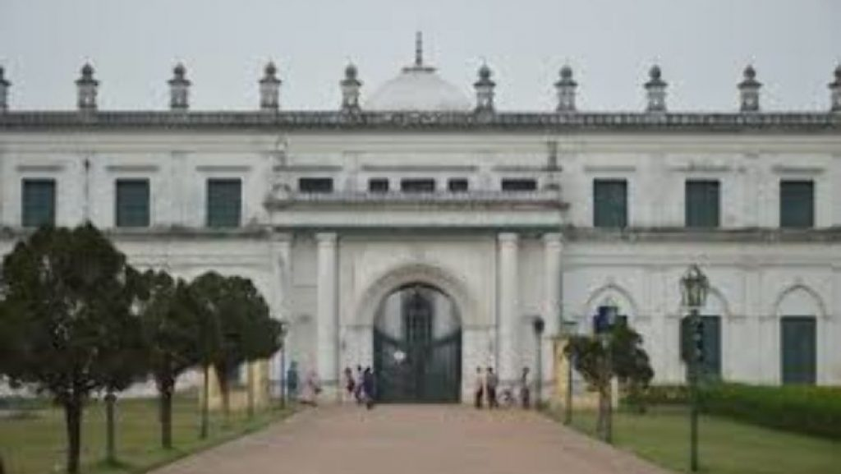

Katra Masjid:

The Katra masjid is an old caravanseria, a mosque and the burial place of the Nawab Murshid Quli Khan .Built in 1723-1724, it is among the largest caravanseries in India.

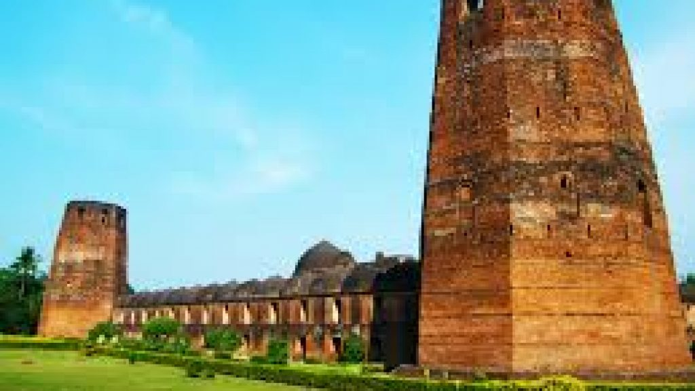 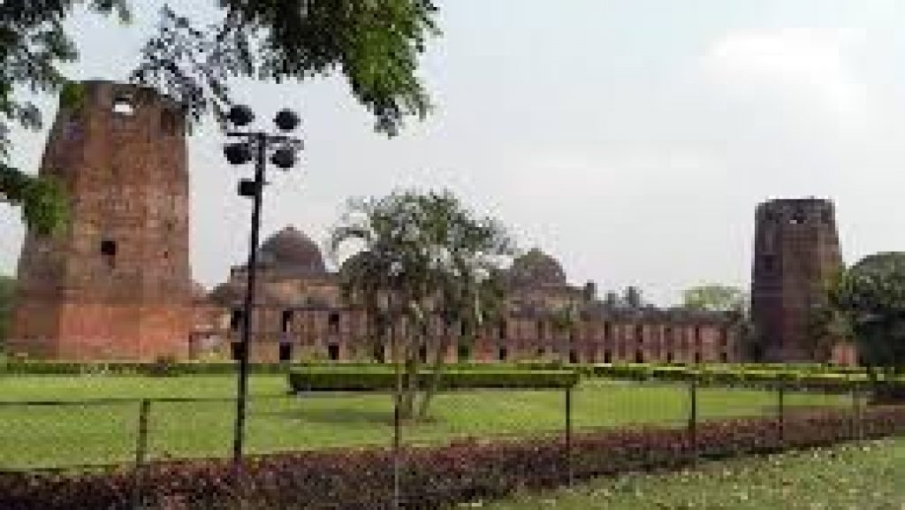

# Char Bangla Dham(Bhawaniswar Mandir) Azimganj:

The Char Bangla Temple at Baranagar in Azimganj, Murshidabad is an exquisite example of Bengal Temple architecture. The temples were built under the patronage of Rani Bhabani of Natore (now in Bangladesh) during the 18th century.

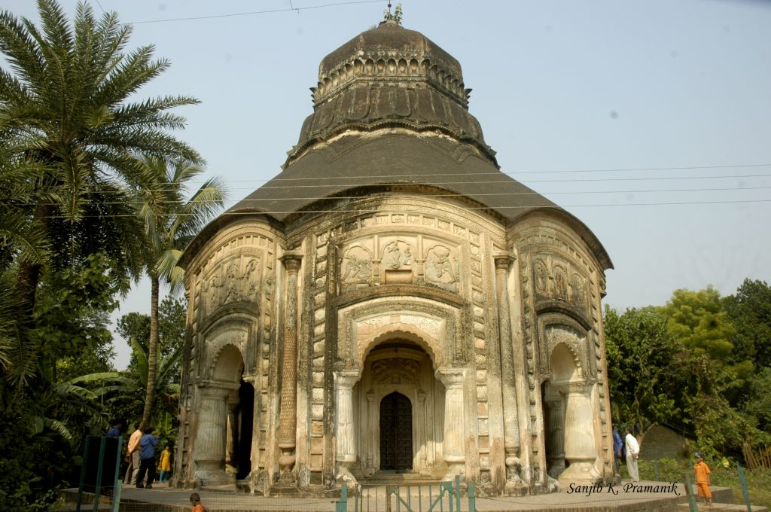 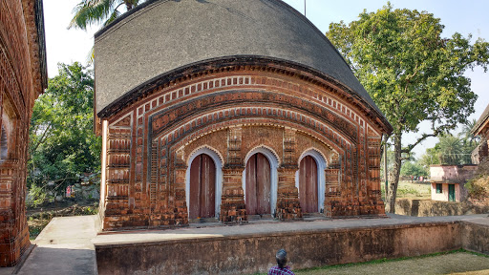

# Nashipur Palace:

# The Nashipur Palace was the court of Debi Singha, who was the expense gatherer of the British during the Nawabi era and was known for being a strict tax authority. It has been converted into Nashipur Rajbari museum showcasing personal belongings of the Nashipur royal family, farmans, legal documents pertaining to tax collection of that time, and other things. The royal palace also has a temple of Ramchandra, which is one of the largest temples across Murshidabad.

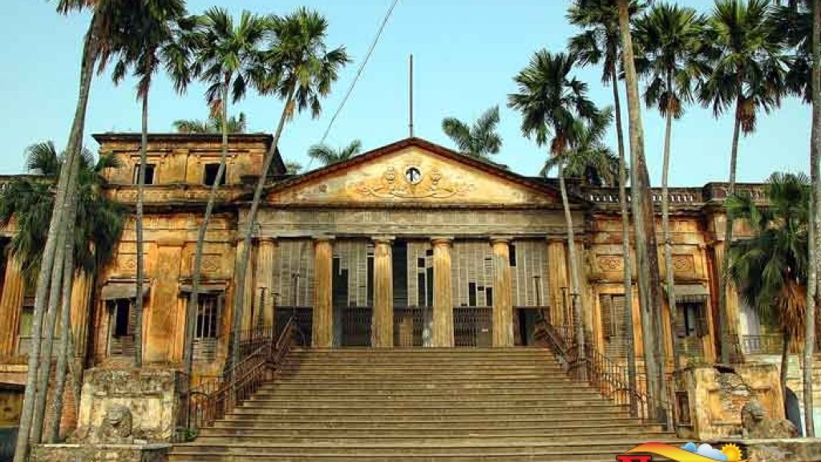

Hajarduari Palace:

Hazarduari Palace, earlier known as the Bara Kothi, is located in the campus of Kila Nizamat in Murshidabad, in the Indian state of West Bengal.It is situated near the bank of river Ganga. It was built in the nineteenth century by architect Duncan Macleod, under the reign of Nawab Nazim Humayun Jah of Bengal, Bihar and Orissa.

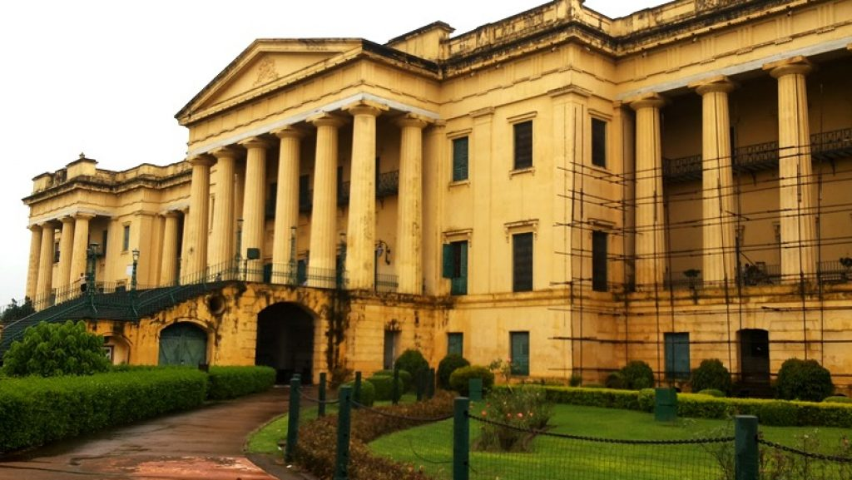 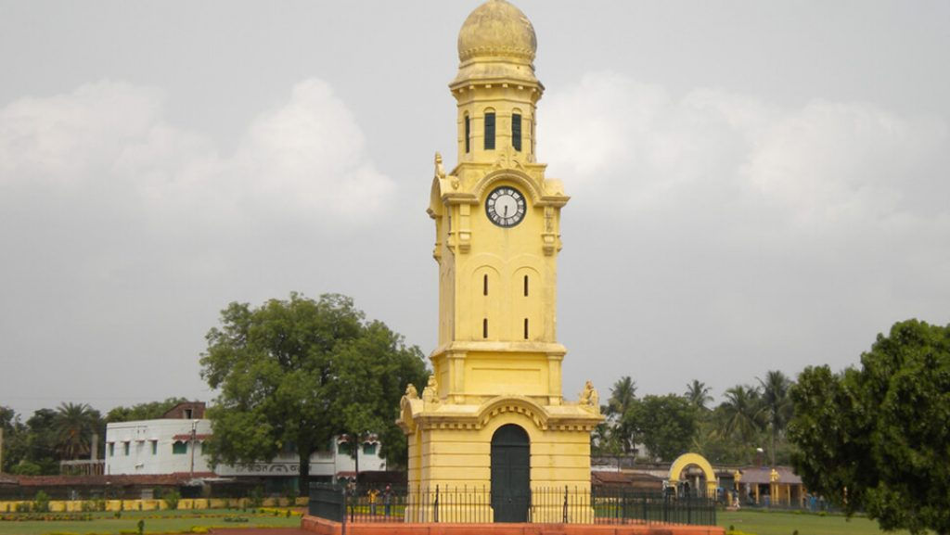 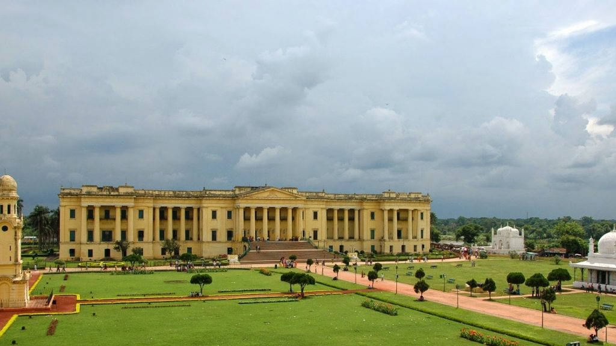

# Kiriteswari Temple:

Kiriteswari Temple is situated in Kiritkona village under the Nabagram in Murshidabad district in the state of West Bengal. This is one of the Sati peeth among the 51 peeths. In September 2023 this area was selected as the best tourism village of India.

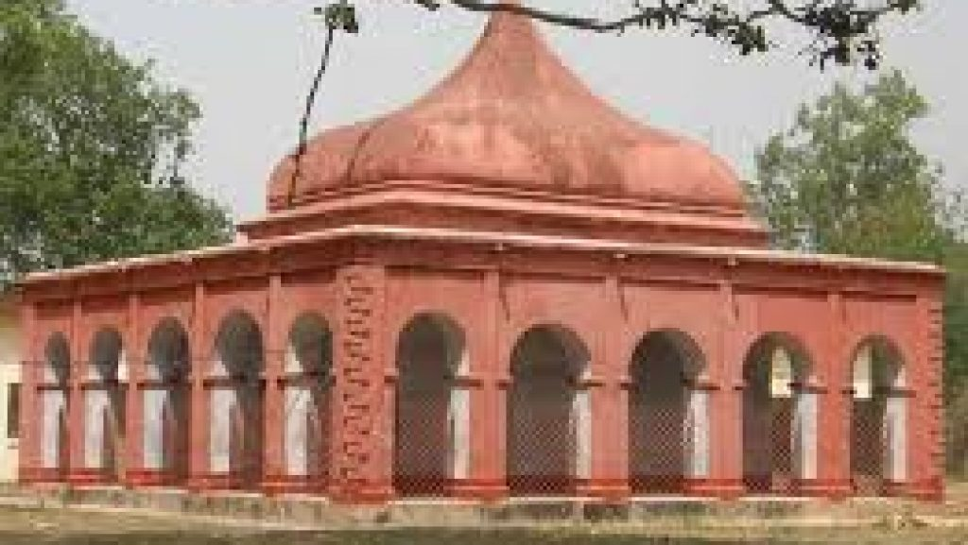 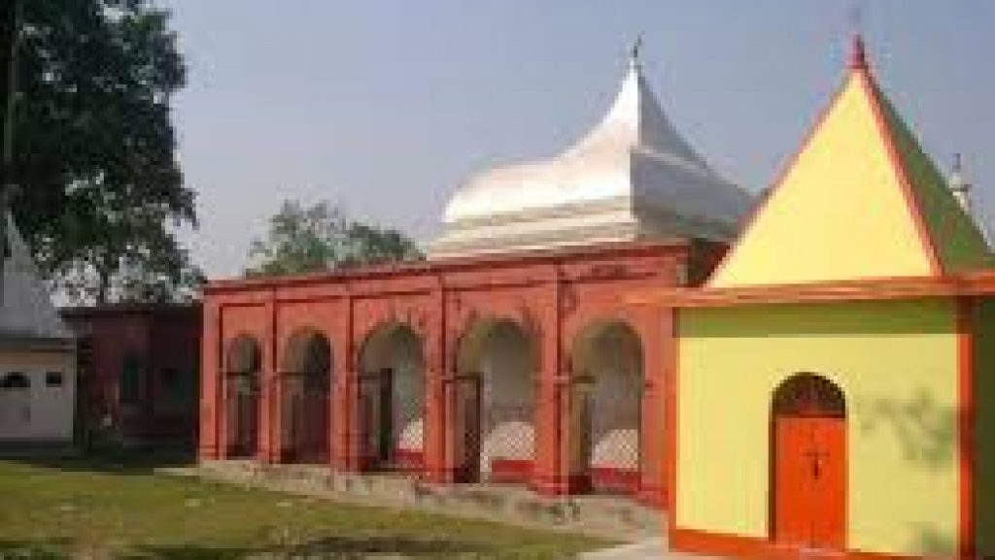 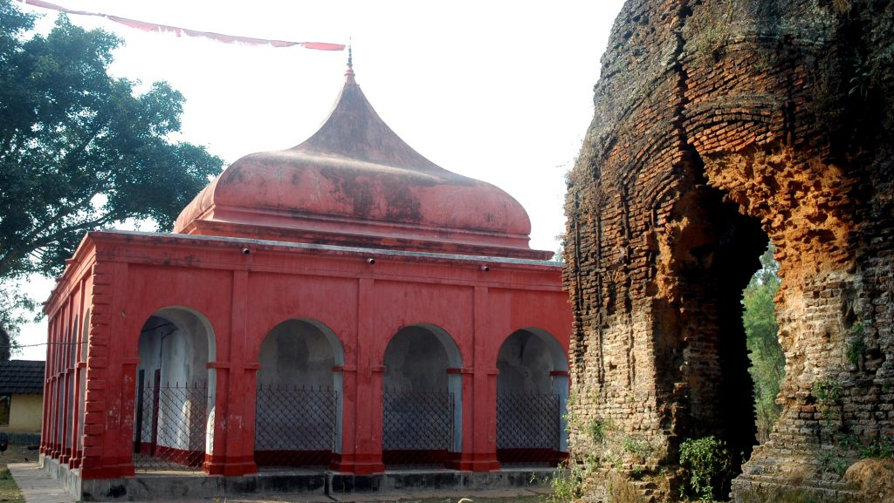

# Culture & Heritage

Bera Utsav :

The main event of this festival is held in Lalbagh. Lalbagh is located at the banks of the river bhagirathi. The venue is located close to the palace of the nawabs. The event is celebrated with the help of traditional dances and music. Fireworks are set off on the embankment of the water. This makes the venue a beautiful sight for the visitors.

The festival is attended by people of all ages, religions and cultures. It tells the story of the age-old glory of the city. It also symbolizes the unity of the people and the love for their culture and tradition.

Hazarduari Mela :

Hazarduari mela is organized by West Bengal state tourism department in collaboration with the district administration of murshidabad. Hazarduari mela takes place on the open air stage with Hazarduari palace as backdrop. Stalls are set up between the palace and Imambara on the south side of the palace ground. The stalls sell handicrafts from Murshidabad area. The mela also features songs performed by local artists from Bauls, Fakirs, Murshidi, Marfati genres.

# Handicraft

The district markets showcase the skills of gifted craftsmen. Ivory carving is a tradition that dates back to the time of the Nawabs, and around 99% of the total production of ivory in the region is exported, which accounts for a large portion of the income of the city. Nowadays, sandalwood etching is preferred over ivory carving. Besides ivory carving, the city is also known for brass ware and bell metal ware.

The silk weaving industry is the main cottage industry in the city. Raw silk weaving has been increasing steadily since the pre –historic period. However, the silk industry of West Bengal is mainly concentrated in the city. The brand ‘Murshidabad Silk’ is not only renowned all over India but also has a high demand all over the world.The sericulture industry is the main agro based rural industry in the city

**[BIRBHUM:](https://birbhum.gov.in/" \o "Go to home)**

Tarapith :

Tarapith is a small temple town located near Rampurhat town in Birbhum district of West Bengal. The city is famous for the temple of the Tantric goddess Tara and the crematorium adjacent to the temple. In Hindu belief, this temple and crematorium is a sacred place of pilgrimage. The name of this place is also associated with the traditional star worship here.

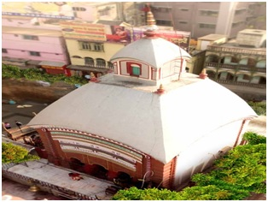

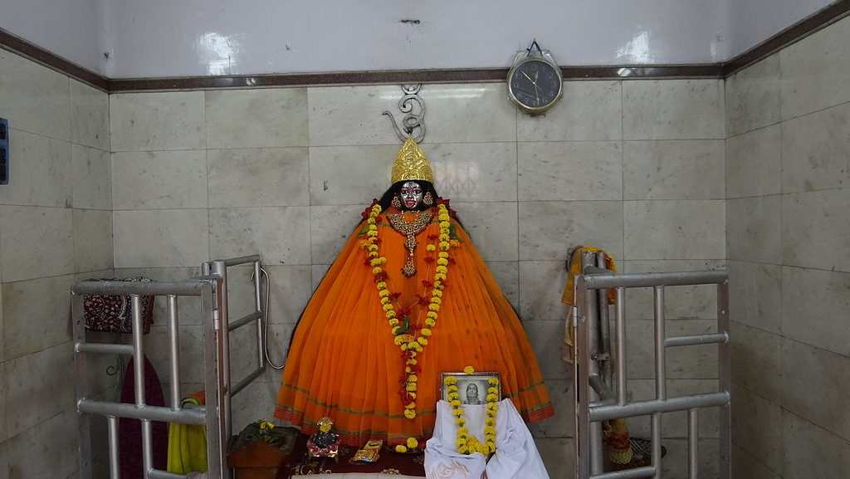

# Nandikeshwari Temple:

It is located in [Sainthia](https://en.wikipedia.org/wiki/Sainthia" \o "Sainthia) [city](https://en.wikipedia.org/wiki/City), Birbhum district of West Bengal.The history of this temple dates back to the time of Sati's self-immolation at her father's yajna Sabha because of his insult to her and her husband Shiva. The necklace from Sati's body is believed to have fallen here and formed the Shakti peetha when Lord Vishnu's Sudarshan chakra disfigured Sati's body from Lord Shiva's arms to pacify his anger.Shiva carries Sati's body to the temple.The present temple was constructed in 1913, which is known as the 1320 Bengali year.

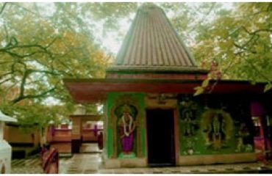

Hetampur, is a large village located in the Suri Subdivision, Birbhum District, West Bengal, India. It is located in the vicinity of Dubrajpur, West Bengal. Hetampur is famous for its Royal and Historical Palace.

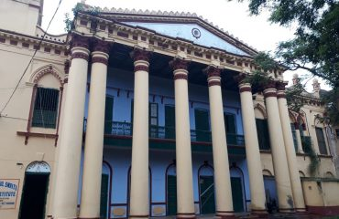 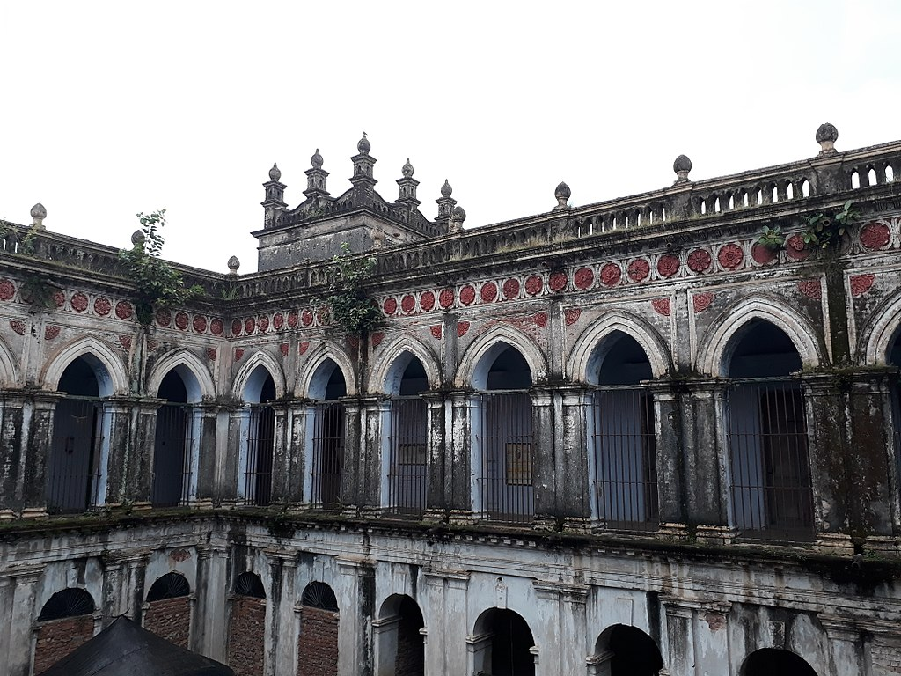

# Patharchapuri Dargah Sharif :

# Patharchapuri is a village in Suri I CD Block in Suri Sadar subdivision of Birbhum District in the Indian state of West Bengal. It is 12 kilometres (7.5 mi) from Suri.

# A Muslim saint named Shah Meheboob but commonly known as Data Saheb is said to have been gifted with miraculous powers and he used to cure dangerous diseases by applying ash.

# DATABABA MAZAR PATHARCHAPURI

Bakreswar Temple:

# The word ‘Bakreswar’ is derived from the word ‘Siva’ which means ‘curved’ in local language. ‘Bakre’ means ‘curve’ or ‘curve-like’. According to legend, during the wedding ceremony of ‘Lakshmi’ and ‘Narayana’, ‘Subrata’ Muni was insulted by ‘Indra’ during the ‘Satya Yuga’. Muni developed 6 ‘cripple-like’ spots on his body (‘Ashtabakra’ meaning ‘6 crooked crippled’ sages’). After indulging in ‘tapasya’ (principles of meditation) for many years, ‘Ashtavakra’ Muni received blessings from Lord Shiva. The site is also known as one of 51 ‘Shakti Piths’ where there is an original Shakti temple. It is one of the main pilgrimage sites for Hindus.

# 

# Kankalitala Temple

# The temple is located on the bank of the Kopai river, northeast of Bolpur, in the State of West Bengal's Birbhum. The presiding deity of the temple is Goddess Sati. It is one of 51 Shakti peeths of goddess Sati. The place where Mother Sati's waist fell is considered to be one of the most prominent places in Hinduism. When Sati's waist (in Bengali, it is called Kankal) fell, it is believed to have caused a hole in the ground, which then filled with water and formed the divine kund.

# There are no idols or statues made of stones, metal or clay in the temple. A framed painting shows Goddess Kali standing atop Lord Shiva. In the temple, the divine energies of goddess Sati and lord Shiva are stored in the form of Devgarbha and Ruru respectively.

# Kankalitala Temple, Birbhum - Info, Timings, Photos, History

Handicraft:

Khoai Hat:

Every Saturday local people come to khoai er hat to sell goods,handicraft items etc. A few rare stalls sell specific items. Atmosphere is good but it becomes more and more commercial.

